

|  |  |
| --- | --- |
| Alford  Academy | AARC Web and Database Information Management System |

***By Jack Watt***

|  |
| --- |
| | Jack Watt |

Contents

Project Proposal 2

Users 2

Project Contents 2

Analysis 3

User Survey 3

User Response Analysis 10

End User Requirements 11

System Research 11

Feasibility study 13

Legal 13

Technical 13

Economical 15

Schedule 15

Project Plan 16

Task Management 16

Deadlines 16

Schedule 16

Resource Management 16

Barriers and Alternatives 16

Specification 17

Test Plan 20

Interface Design 22

Program and Data Structures 29

System data flow diagrams 30

Data Structures 32

PHP Data Processes 32

Implementation 37

Appendix: 38

Alpha Testing and Debugging 51

Beta Testing and Debugging 51

Evaluation and Development Path 51

Release Notes 51

# Project Proposal

The Project in mind is a small local area network web service managed by a server machine to serve up and distribute data to the connected machines accessing the required data via an internet portal created to provide the functionality the users require.

The web service would provide data and enquiry mechanisms to the members of the Alford Academy Robotics and Code Club to query a server-based database and website showing club inventory or resources such as animations, diagrams on how the network was built as well as documentation on how to maintain the web service and software/files.

The Project in should also have a purpose-built reporting and feedback feature.

## Users

The robotics and code club at Alford academy will need places within the school to work using software not available on the school systems and have less restricted access to system operations.

Identified needs of the user group is that the club has multiple members and one machine needs to be able to access their data that they might have been working on at different machines.

The second initial identified requirement is the need to search the robotics inventory especially if new kit is planned on being ordered in case it is already in storage; this brings the need for queries and the ability to amend the database.

A third initial requirement for the project is the documentation and resources used to create this network along with the necessary instructions which will allow new members to become familiar with the project, learn how to set up their own basic network and maintain the existing one available to them.

## Project Contents

The Project makes use of databases hosted on a server which I am familiar with.

On the server side, a search field which will use a sort and search algorithms as well as appropriate data structures. The Website must have a simple but user-friendly feel that contains forms and search boxes as well as a clear hierarchy for navigation.

# Analysis

The AARC Web and Database Information Management System will main and primary users are the Robotics club with the occasional exception of school staff or guests.

The Web based survey below shows the results from the end user group and several case exceptions in repose to an extensive set of questions relating specifically to the project without too much detail to determine suitability and feasibility.

## User Survey

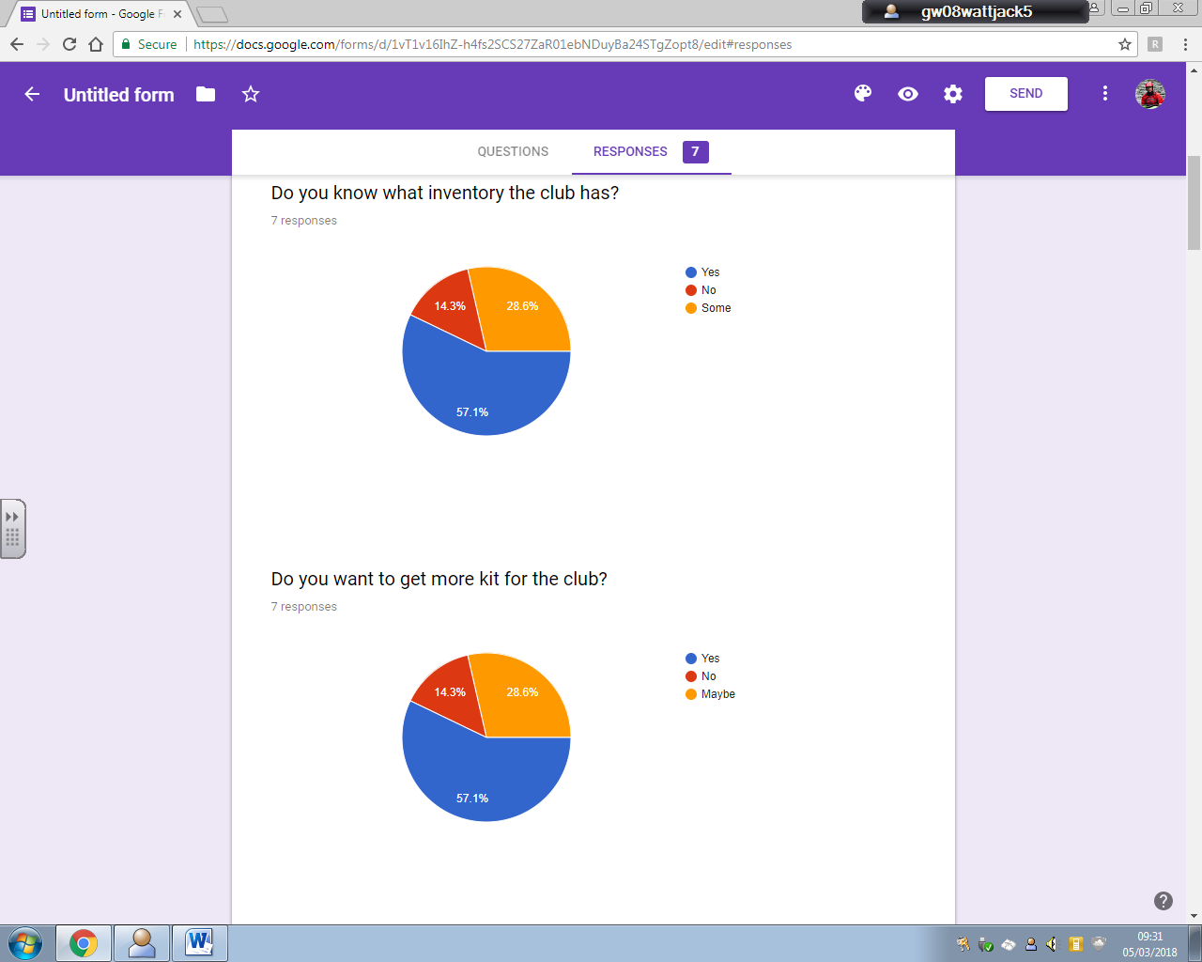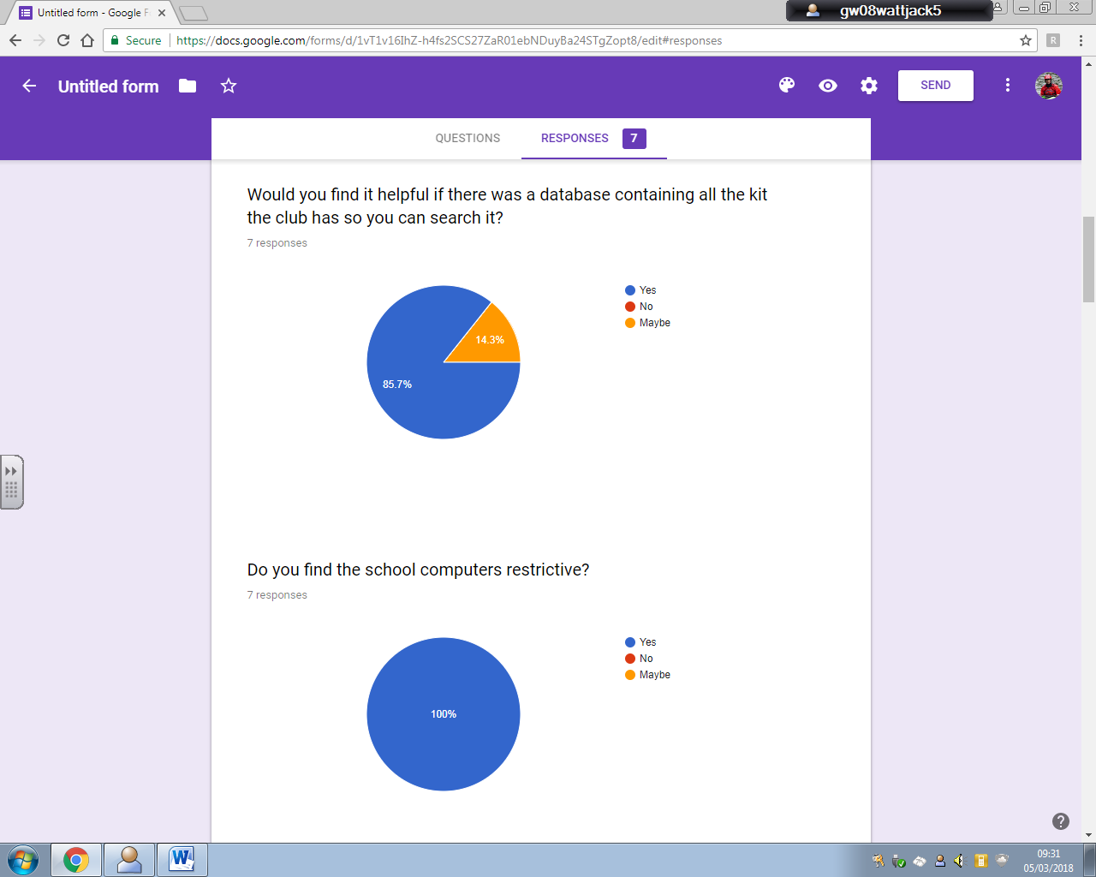



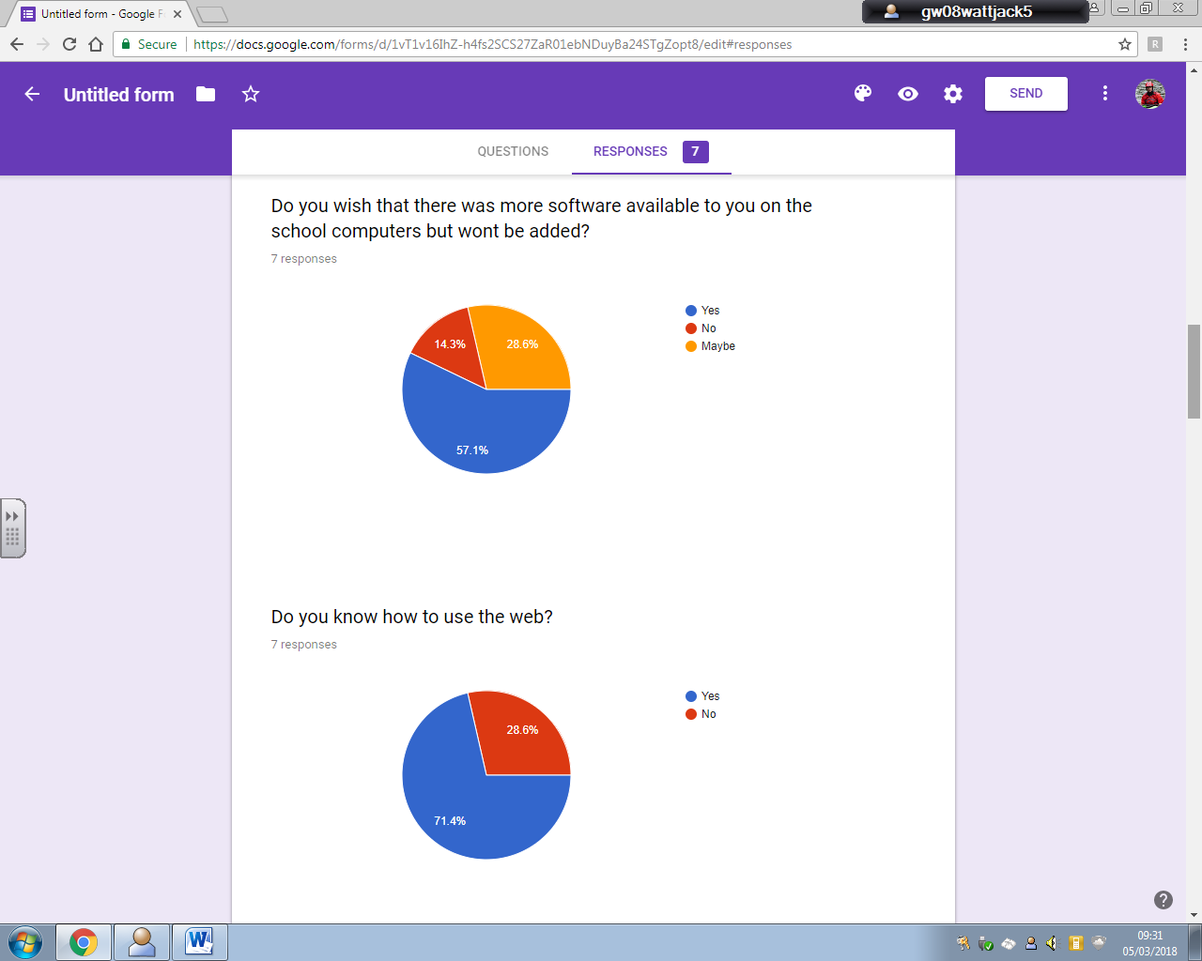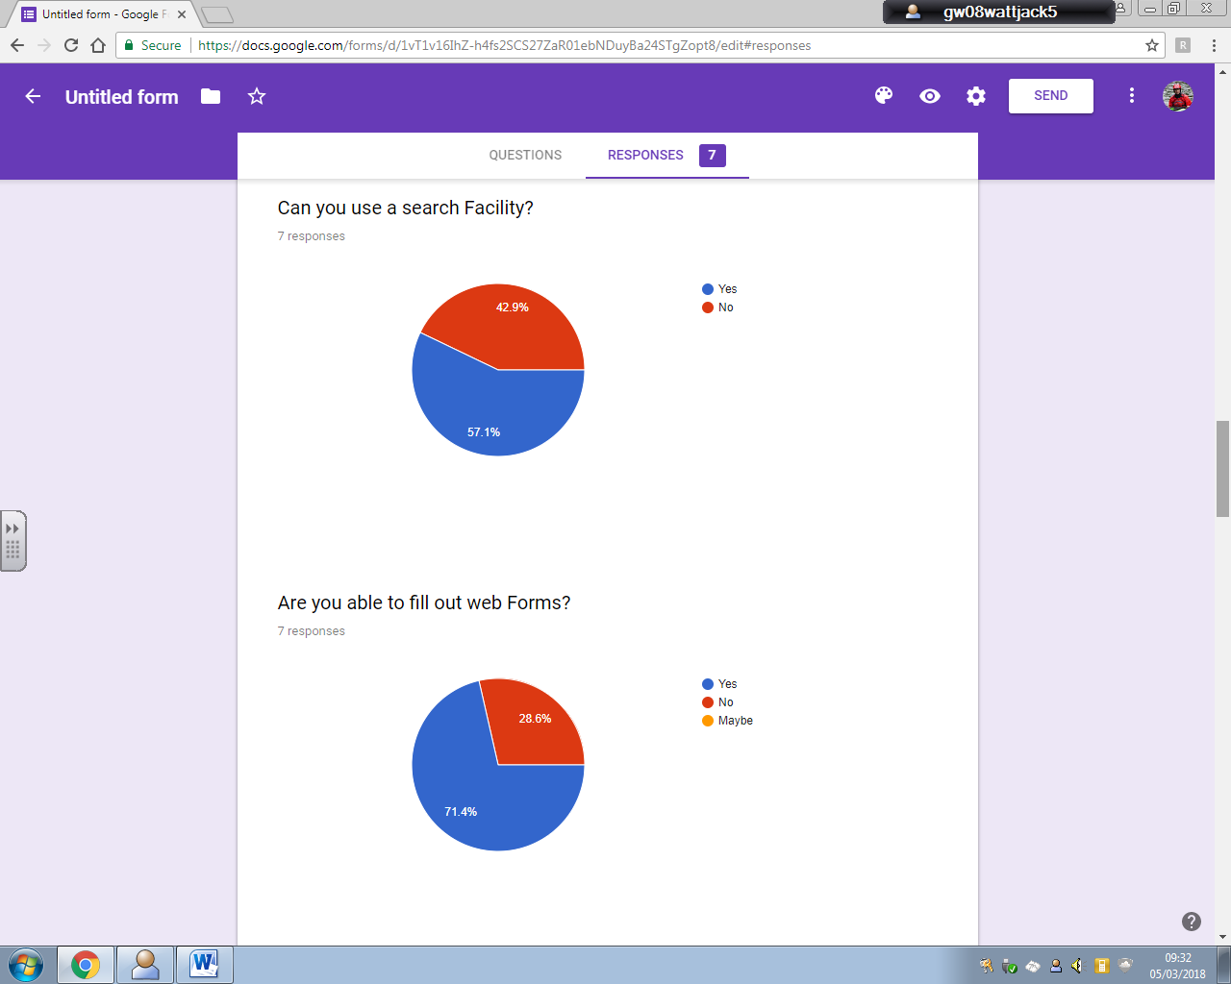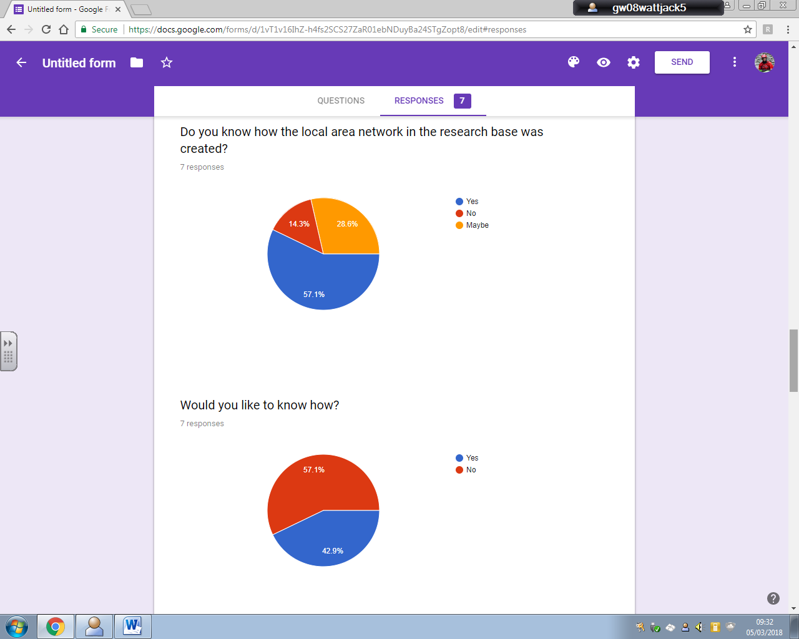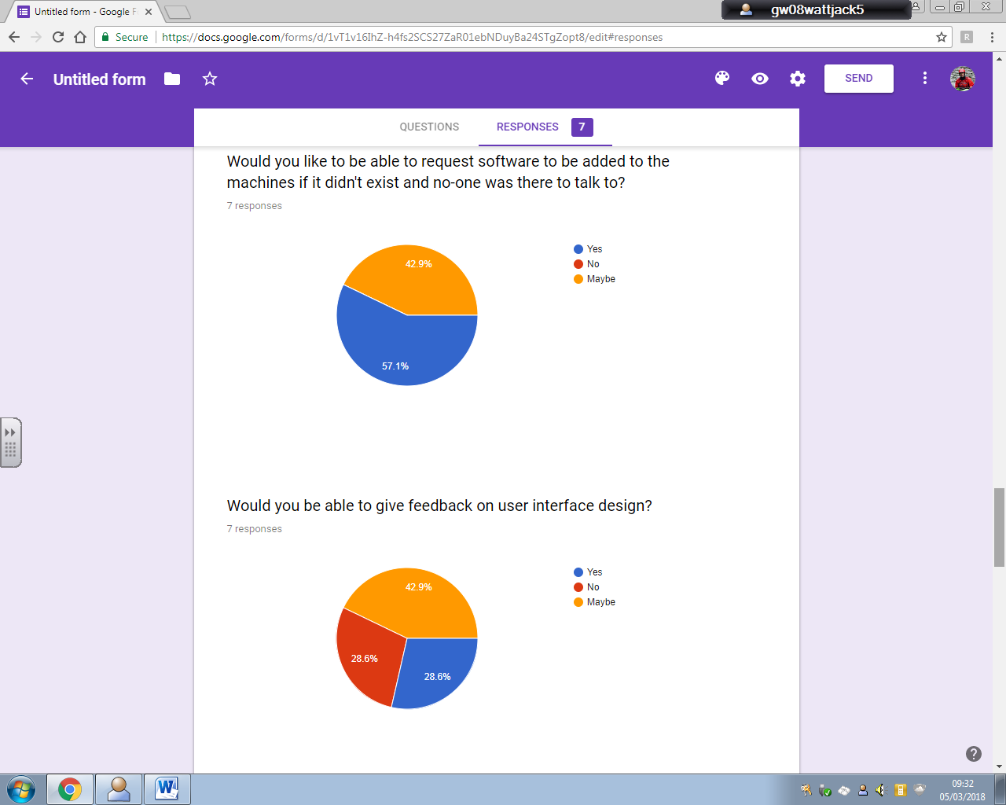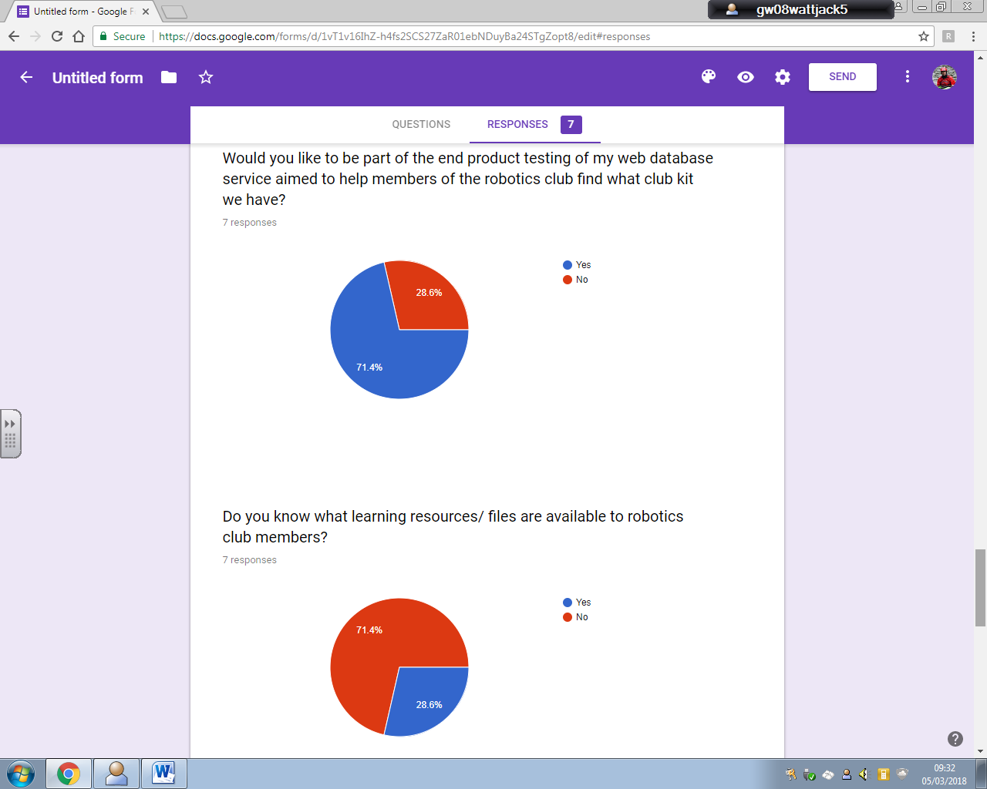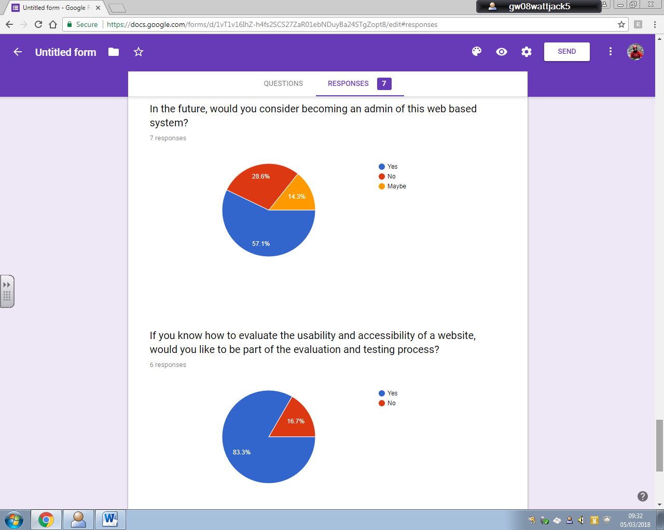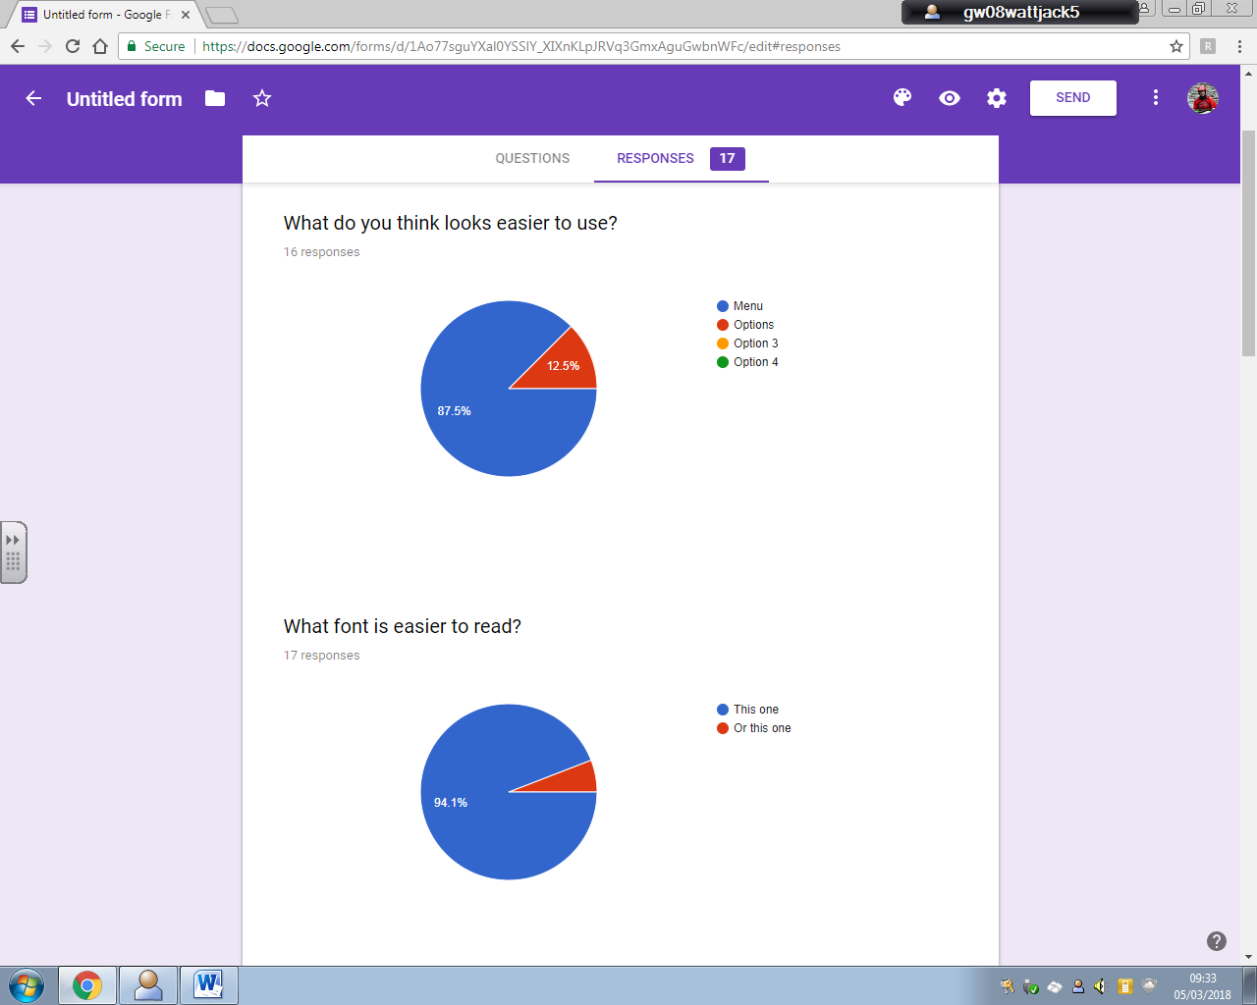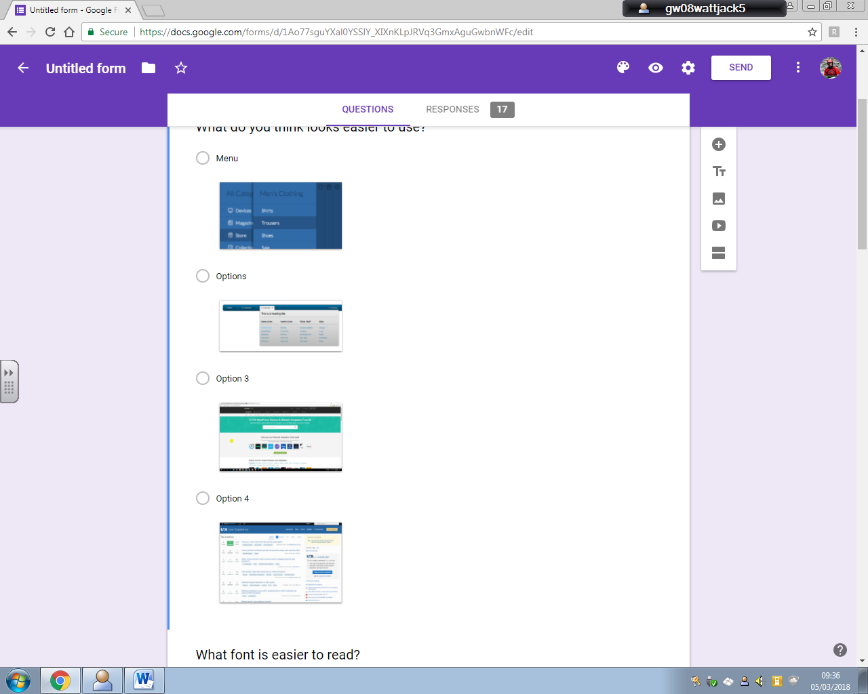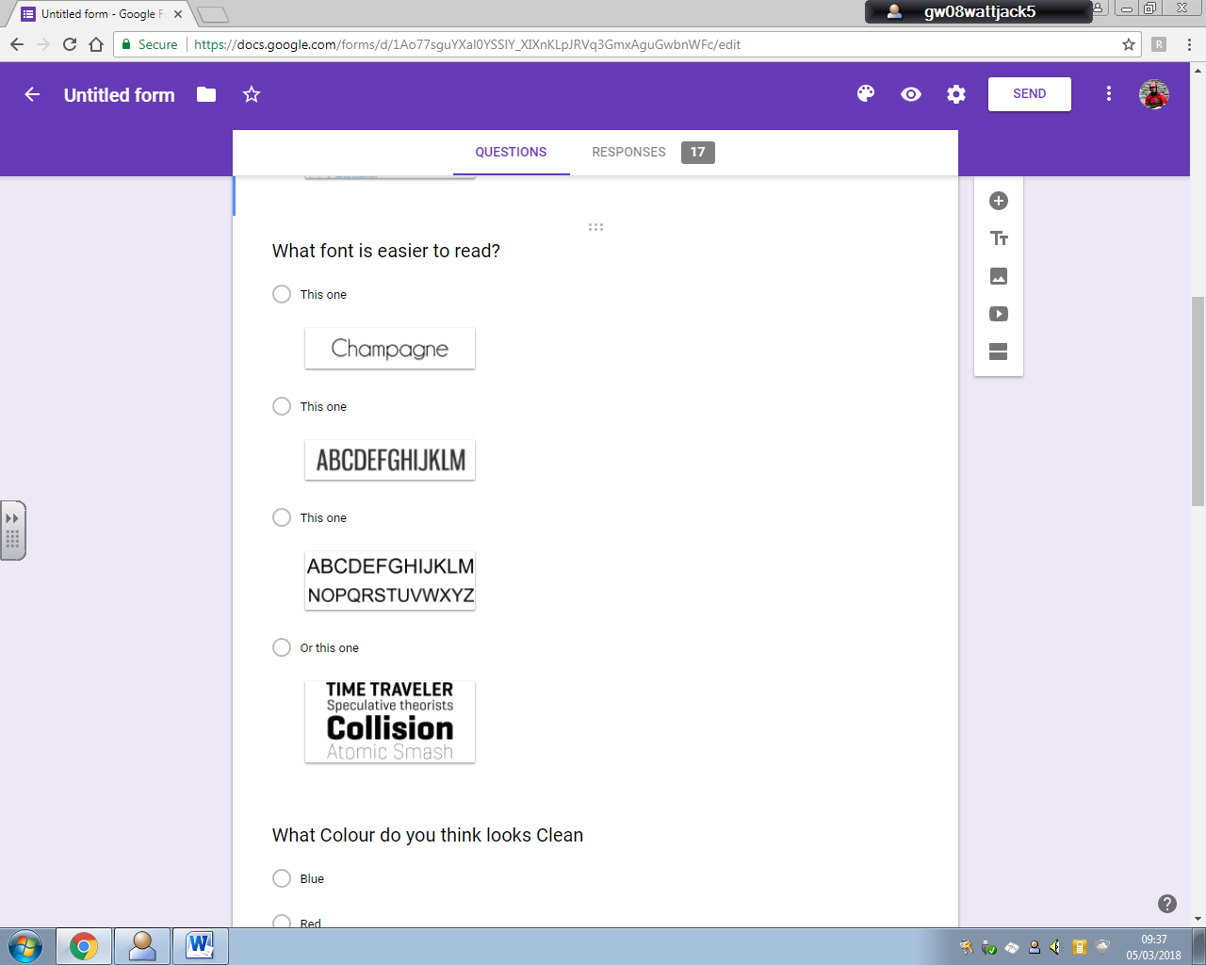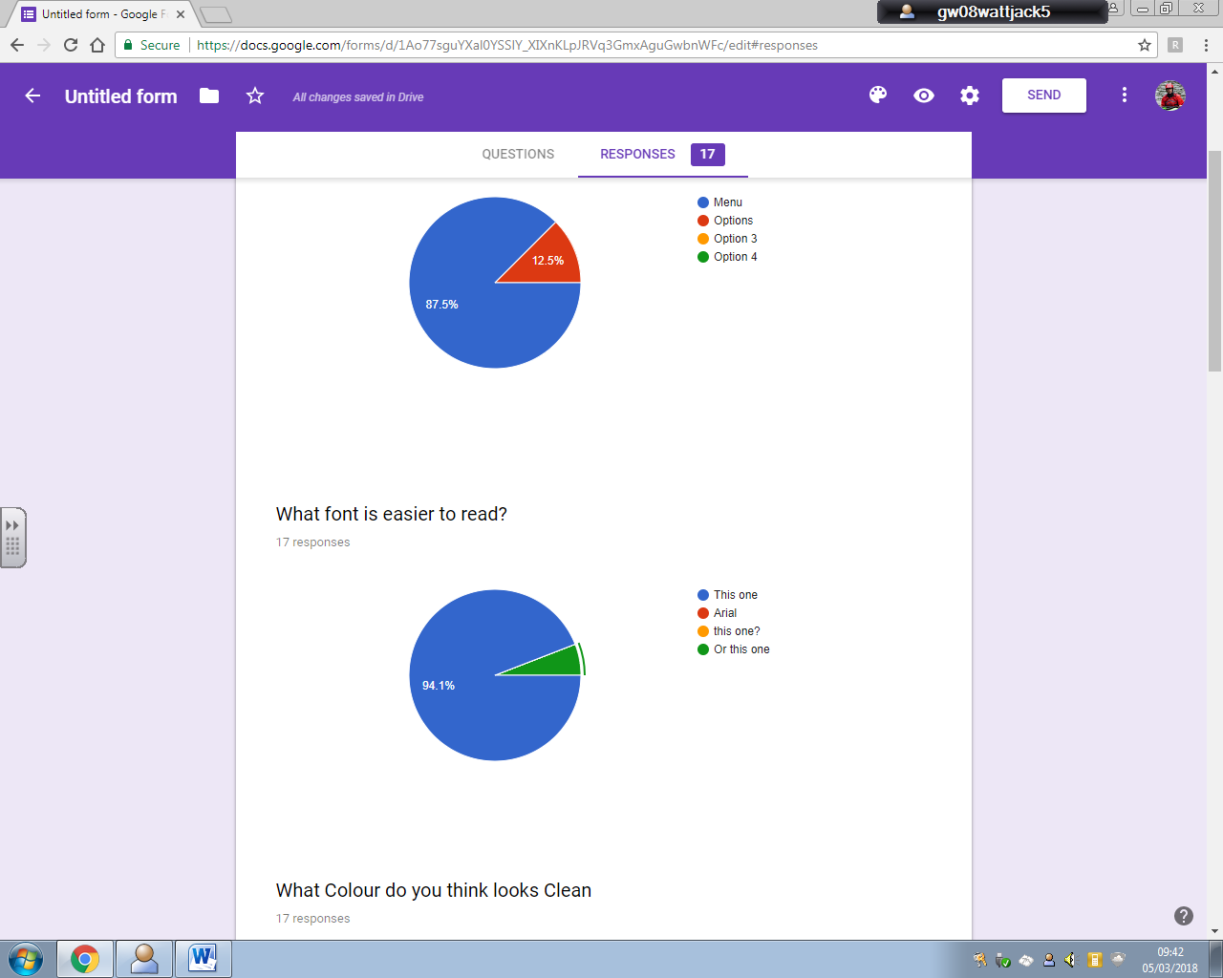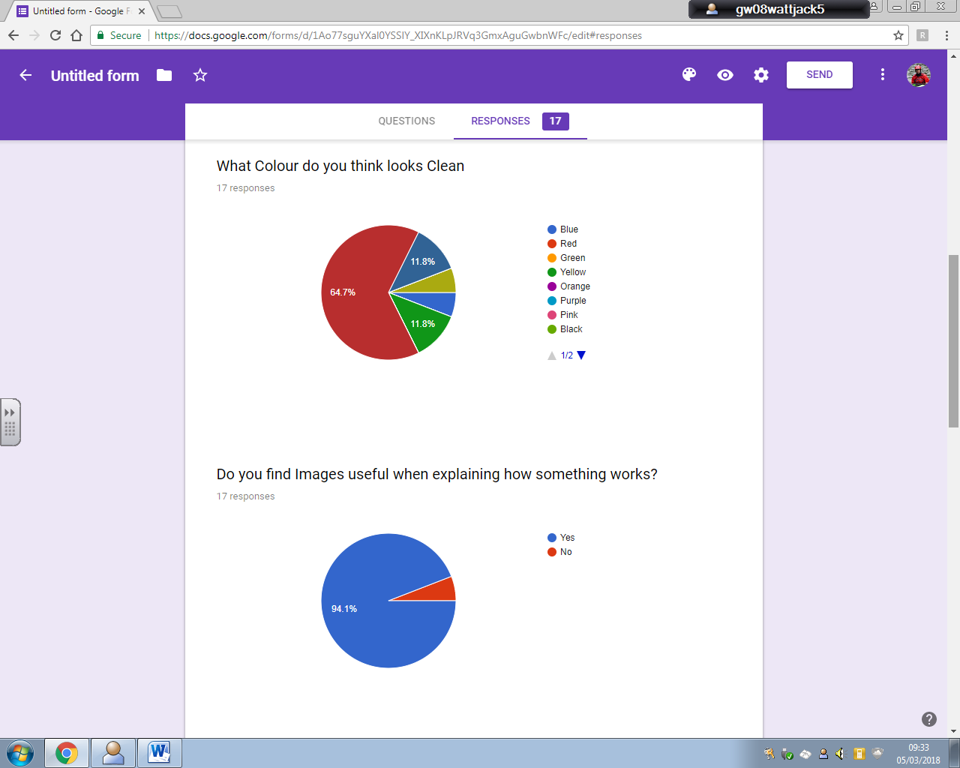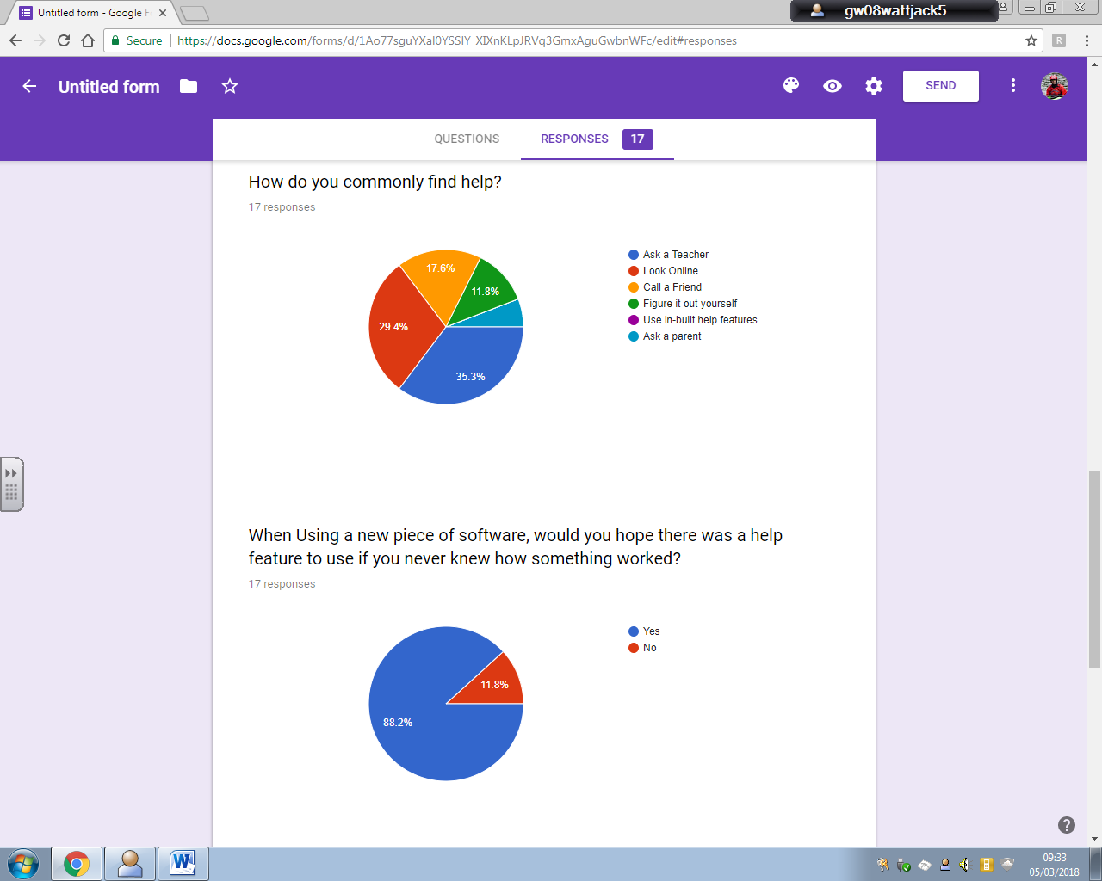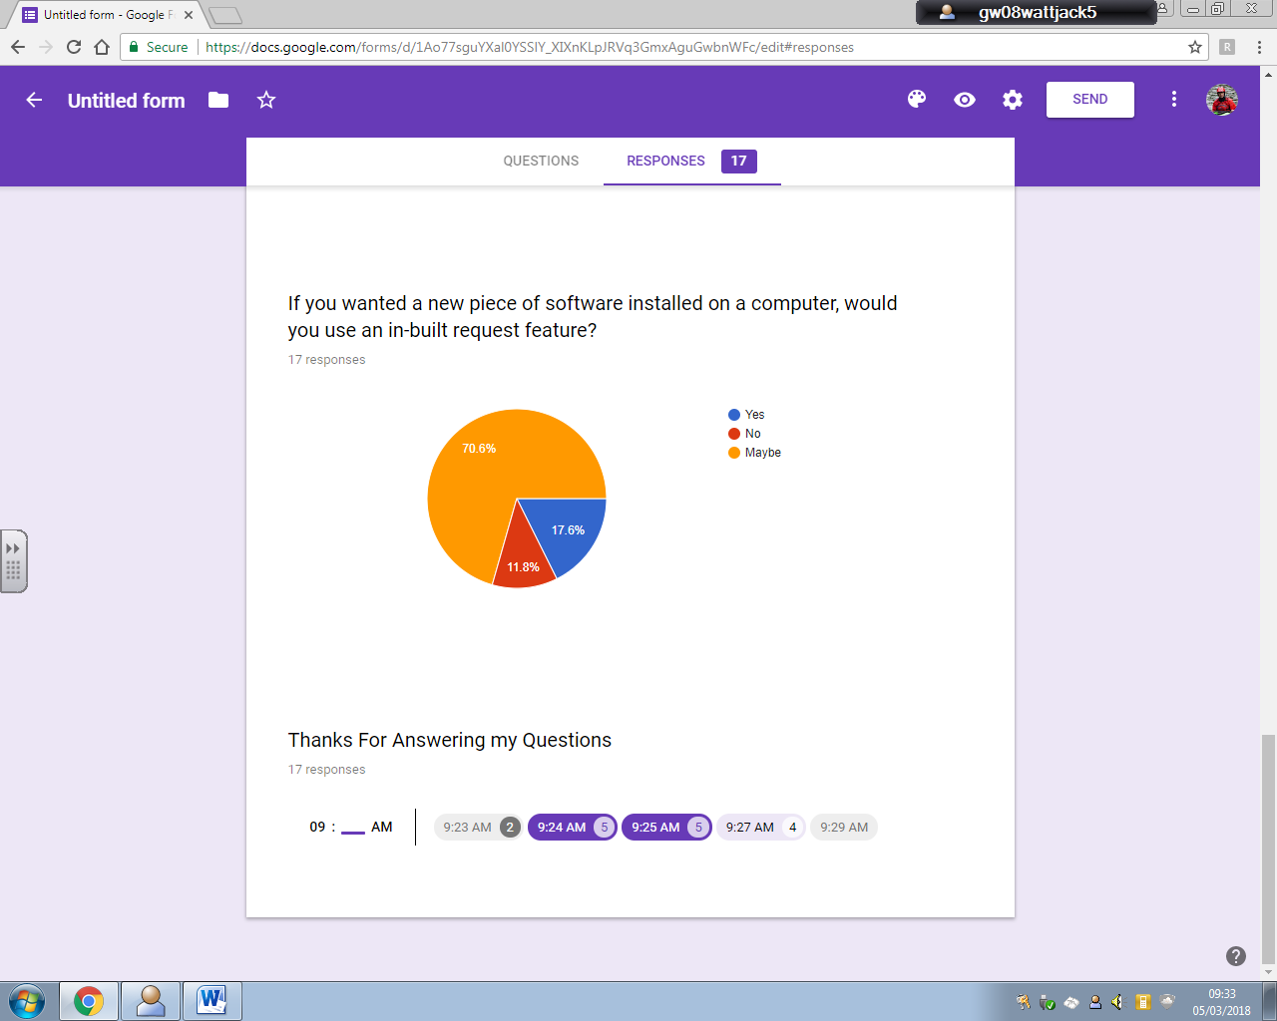

## User Response Analysis

It was noted that most end users have an idea about what the club itself has but they would like to have more available and easier way to find out what there is.

All the End users also expressed that while they have enough knowledge to be able to use the system even though a help and simple user interface would be used.

There is also interest in a logging system for data and software that is wanted on the system which would be web based.

While 57.1% of the club have an idea as to what kit the club has, but 85.7% have acknowledged that they would find it much more useful to have a database with kit listed so they can see everything the club has and in more detail.

There is a general response of 57.1% saying that they would like to see more kit ordered for the club. A database system in this case would ideally allow members to find kit the club does not own so they do not order kit already existing.

All of the Club members find that the school system is very restrictive, and this includes a lack of software they would like which the system would hopefully be able to provide or make available for members to request which the club members in majority agree should be available.

Around 85.7% of the club know of the pre-installed network and 57.1% know how it was made eliminating the need for extensive detail on how the network was setup but providing enough for new members to learn if they would consider it..

Finally, ¾ of the club would be eager to help test the site and evaluate it.

As part of a survey of youth school pupils who are of the same age as club members, feedback on user interfaces and designs provide an insight into how the website should look to make it easy and useable.

87.5% though that he Side, pull out menu looked easier to use that a traditional drop down or other navigation techniques.

94.1% of the youth survey recognised the Champagne font to be easier to read.

64.7% said that Red as a colour looked clean/tidy with 11.8% choosing blue and yellow as well where other colours in the spectrum were deemed to be less clear or associated with mess.

Asking a parent and looking online took the majority votes for the main ways to ask for help. Therefore, hoping to capture the attention of the 30% online users would be the in-built help feature highlighting the main features of the website as 88.2% of the survey would hope there was a help feature available.

88.2% of the survey was keen or unsure whether or not they would like an in-built request feature in the context of getting help online. In the case of the robotics, this meant that the request feature might only be used by admins to get things logged rather than the main set of users accessing the feature.

## End User Requirements

From the survey and project proposal ideas, this list contains a list of features to be featured in the project;

* A Inventory Database
  + Kit Table
  + Software Table
  + File Table
* Simple Forms for Database Queries
  + Kit Table
    - Queries
    - Admin Table Amend Form
  + Software Table
    - Queries
    - Admin Table Amend Form
  + File Table
    - Queries
    - Admin Table Amend Form
* Linear documentation page navigation with page numbers at top to skip to specific pages
* Easy site navigation
* Simple user interface and Design
* Multi machine single user data access
* Upload and Save onto a User database on the server
* Report Issue/Admin Request Feature
* Detailed Information on the system
* Help/tutorial feature (quick)
* Xampp and Apache Service

## System Research

A distributed database was considered for this project, where the database storage mediums are part of different sets of hardware attached to separate processors. This means that the database can be all across the world but have to work together through organized network servers, decentralized independent computers on the Internet or on corporate intranets.

The distribution of the data is spread across the network of database servers at different physical locations. Distributed databases can improve performance for users by allowing transactions to be processed on many machines, instead of being limited to one which decreases the load a single machine and processing time for a single request is faster as less resource allocation is required when dealing with different requests concurrently.

However, due to the scale of the task and the volume of traffic expected to pass through the server, this was considered to be overpowered and unfeasible as not only was the software unavailable, the current deadline for the project would not be met as it would take too long and keeping data up to date is important since data integrity can be lost requiring specialised software to identify changes across the network and then updating all other databases.

So a traditional single server database system was chosen as its maintenance and implementation are far more suitable the current time available and make use of software already available.

## Feasibility study

### Legal

None of the website or databases will draw from sources other than club created content removing the copyright issue factor from the final system.

There is no personal data being stored and as user accounts are standard and created by an admin, there is no need to regulate the data under the Data Protection Act however its protection as an asset is a concern.

Passwords and Usernames will be in place to prevent unauthorised users gaining access to the system naturally discouraging computer misuse.

System communication with users is strict and prevents data being read by other users as well as barring bad reports into the system from external users.

There are no security threats from external sources since there is no internet access and therefore only hardware vandalism and members with intent to be malicious will be able to attempt to sabotage the system hence why user permissions set by the admin will regulate the system users’ ability to perform certain commands.

### Technical

The level of programming required is not beyond the capabilities of the programmer and the hardware to perform the tests and implementation is low level and already in place.

There was a need to establish our own private network for the club to allow software to be run without the restrictions in place from the Local Authority as well as trial new software.

I decided that this network would host the club inventory software on this private network.

Setting up this Physical Network required;

* 1- 8 port Unmanaged Switch
* 6- HP Compaq dc7900 SFF PCs
  + 4 - Running Windows 7 Home
  + 2 - Running Windows 10 Home
  + Intel Core 2 Duo E8400 @ 3.00GHz
  + Intel HD Graphics 4600
  + 4 GB of DDR2 RAM
  + 64 Bit Architecture
  + 500GB HDD
  + Varying monitors of HP, Ilyama and Belina
* 1- Raspberry Pi – B
  + 4 USB 2.0 Ports
  + Ethernet Enabled
  + Samsung 16” Monitor
* 1- Acer Predator
  + Running Windows 10 Home Premium
  + Intel i7-950 @3.07GHz
  + 6GB DDR3 RAM
  + Nvidia GTX 470 Reference
  + 1TB HDD
  + 4 USB 2.0 Ports
  + 2 USB 3.0 Ports
  + 1 eSATA Port
  + Dual Ethernet
* Xampp and Apache Server Side Hosting Software
* Web Authoring Package (Notepad++)

The Network is setup with 8 Devices connected to the unmanaged switch via 8 Cat5e cables enabling 1GBit Ethernet both ways.

Any of the ports in the switch can be hot swapped with new devices to allow them to be connected to the network but in order to do so, the new device would have to be configured with a manual IP of 10.1.1.# and IPv6 Disabled and a manual network mask of 255.255.0.0.

The Network design is a Star network like so,

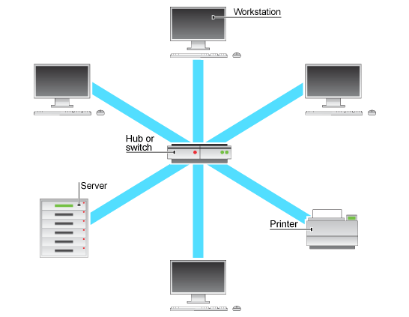

This Setup Shown has the Server PC as 10.1.1.1 and the Printer as 10.1.1.100 and the first 6 PCs connected already are 10.1.1.2 through 6.

The printer is a Xerox Phaser 3610 but only the 3 Windows 10 PC’s have the correct drivers installed.

All Windows PC’s required network discovery to be turned on and have a Script I created in the start-up folder so that when a user logs in, it maps a network drive to the Server Machine for file sharing under a virtual user called shareuser.

5 User accounts have been created identical to each other using a bat script and an admin account is enabled and named localadmin across all machines.

That is the network setup with physical and digital configurations.

### Economical

All of the hardware provided was free from Robert Gordons University and software installed has been provided for free or is open source. The network also is running inside the school so therefore the cost to the client, AARC, is £0 since there is no running cost, setup costs involved or space rental costs.

### Schedule

The project should take no longer than three months. The System should be fully implemented and be under test before the required deadline so that the completed system can be fully evaluated by the users and reported on before the final deadline.

# Project Plan

### Task Management

The System specification must be completed before system design and test plan is completed.

The Designing and Test Plan Development can be completed concurrently.

The Implementation of the System cannot commence until the System design is completed.

The Testing of the System can begin after most of the Development has been completed.

The User Testing (Beta) cannot begin until the Alpha testing has finished.

The Release evaluation cannot be completed until the Beta testing is over.

Final Deadline is 20th of April.

### Deadlines

Test Plan - 05/03/18

Design Phase- 09/03/18

Implementation Phase - 06/04/18

Alpha Testing Phase - 06/04/18

Beta Testing Phase - 19/04/18

Evaluation and Documentation Phase - 20/04/18

### Schedule

### 

### Resource Management

Files will be kept in 3 places, on the server machine, a USB drive and a second PC as a backup. This can ensure that there is not a loss of progress.

A selection of reference documents will be kept on a shelf behind the server for use while implementing the design.

### Barriers and Alternatives

Significant barriers to the development process is that the Local Authority doesn’t allow us access to setup web services within the school or connect to hosted web services out with the school.

The alternative was to create an in house server/service provided to an intranet of machines with no external connection to ISP’s or Local Authority Servers.

# Specification

The whole system is designed for the members of the robotics and coding club to be able to access and see the details on club stock, inventory and resources available to use. This will provide them with details such as the last time the inventory was checked alongside the ability to upload their files, code and software to the service. This will be a database driven service.

It will also make available the tools for admins to alter and amend the databases and manage the server for dealing with request from users and any bugs that might be thrown at them.

The Server will be a GUI web interface hosted on a server machine providing users access to the database.

Inputs:

* Files
* Kit Data
* Software data
* Search Criteria
* Sort Criteria
* Admin Password
* Error Reports
* Screenshots
* Text Input
* Dropdown menu Selections

Output:

* Kit Table Data
* Software Table Data
* File Table Data
* Network Documentation Pages
* Error files on Server Desktop
* Help Overlay

* Basic user database queries

These will allow the users to be able to query the AARC database for their specific search.

The files will allow club members to download shared files to make copies of.

It will take search items and a sorting type before displaying the results.

The sort will be by field and will be manually programmed.

* Admin user database amend form

These allow admins to add new kit to the database as well as alter previous entries provided they know what they are looking to alter.

It will also be able to display contents of tables so that the admins can review current data in the tables before deciding to alter the contents.

* Admin log in feature

This feature will allow the admins access to the Amend and Alter forms used to update the database provided they have a password that matches the admin password.

* File Upload Feature
  + Table interface form
  + Save file feature to a server library
  + Table auto update with file details

This will allow club members to upload files they have created or altered to the file table and server file library. The Files uploaded will contain all the details the PHP will require to update the table without the user having to add anything other than their name.

* Home Page
  + Navigation Bar
  + Left side pull out

These features will allow a brief overview of the web portal and its features as well as a good structured way to access each page and its contents including database forms and network documentation.

The user will only have to select an option in the menu to navigate to the page required.

* SQL Table for Kit, Software and Files
  + In AARC Database

These tables and database will store the contents of the AARC inventory of all software, files and kit. It will provide the web based users’ access to the contents as well as admins the ability to alter the contents from the web based forms.

* Help and tutorial button with appropriate guidance on how to use the site
  + Home Page
  + Table Query Page/Forms
  + Login Forms

These features will provide a detailed breakdown of each element of the site including how each item works as well as what it does.

The JavaScript will blanket the page with a semi-transparent layer only revealing each item as they are being detailed.

* Documentation page with basic network setup details
  + Linear Page layout
  + A4 size Documentation

This linear navigating documentation set will allow a quick overview of the network and its build as well as contain images/relevant animations so that interested users can see the network setup and the database setup so they can build their own or maintain this one in the future.

* Admin report feature to log issues
  + Text input and screenshot attachment

This will be a Form allowing the system users to log errors and make requests for software etc, without the need to find another human to ask.

It will contain the ability to note down issues, add screenshots or add software installation files so that the admin can access each request from the server machine. They would be stored as rich text format documents to allow screenshots to be stored as well as have an auto generated file path for any uploaded files.

# Test Plan

|  |  |  |  |  |  |
| --- | --- | --- | --- | --- | --- |
| Test Area | Test Item Set | Test Object | Test Type | Requirement Fulfilled | End User Testing |
| User Interface | Home Page | Navigation Bar | Rolls out on hover |  |  |
| Internal Links | Links work Properly |  |  |
| Image Display | Loads correctly |  |  |
| Usability | Users find it easy to use |  |  |
| Admin Page | Login Form | Functionality |  |  |
| Form Usability | User Response |  |  |
| Form Clarity | User Response |  |  |
| Database Table Display | Functionality |  |  |
| Network Page | Page Links | Functionality |  |  |
| Document Text Size | User Response |  |  |
| Upload Page |  |  |  |  |
|  |  |  |  |
| Request Page |  |  |  |  |
|  |  |  |  |
|  |  |  |  |
| Database | Club Database |  |  |  |  |
|  |  |  |  |
| User table |  |  |  |  |
|  |  |  |  |
| Checker Table |  |  |  |  |
|  |  |  |  |
| Resource Table |  |  |  |  |
|  |  |  |  |
| Inventory Table |  |  |  |  |
|  |  |  |  |
| Request PHP | Request Form |  |  |  |  |
|  |  |  |  |
|  |  |  |  |
|  |  |  |  |
| Help JS | Home Page |  |  |  |  |
|  |  |  |  |
| Network Page |  |  |  |  |
|  |  |  |  |
| Report Page |  |  |  |  |
|  |  |  |  |
| Login PHP | Form | Password Censorship | Functionality |  |  |
| Password Submission Validation | Functionality |  |  |
|  |  |  |  |  |  |
|  |  |  |  |  |  |
|  |  |  |  |  |  |
| Upload Form | Form |  |  |  |  |
|  |  |  |  |
| PHP File Handles |  |  |  |  |
|  |  |  |  |
| SQL Database Updates |  |  |  |  |
|  |  |  |  |
| HTML and PHP data transfer |  |  |  |  |
|  |  |  |  |

# Interface Design

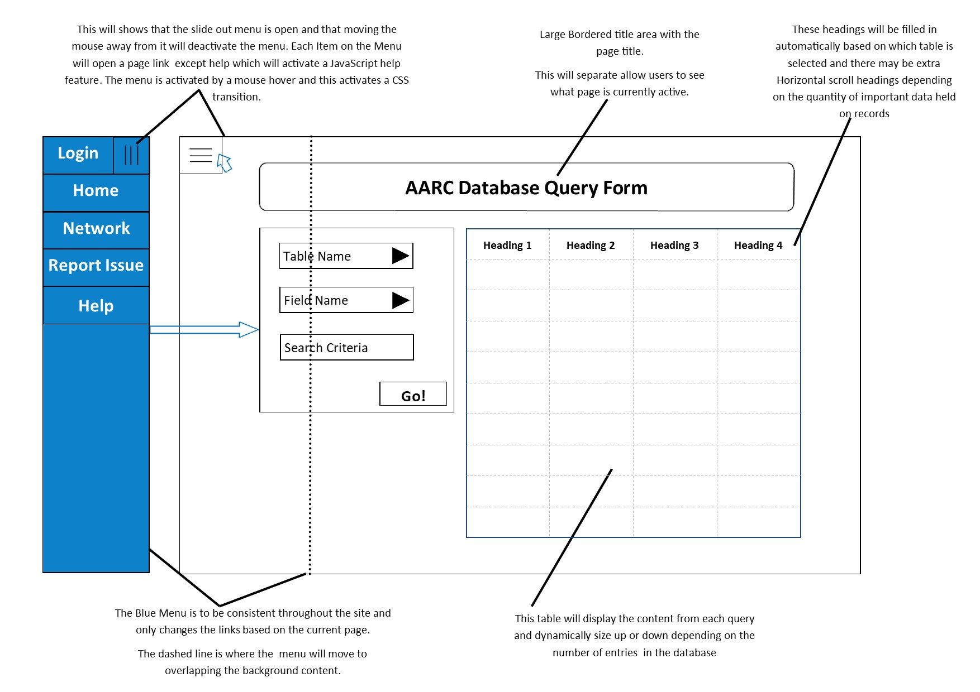



**Admin Controls**

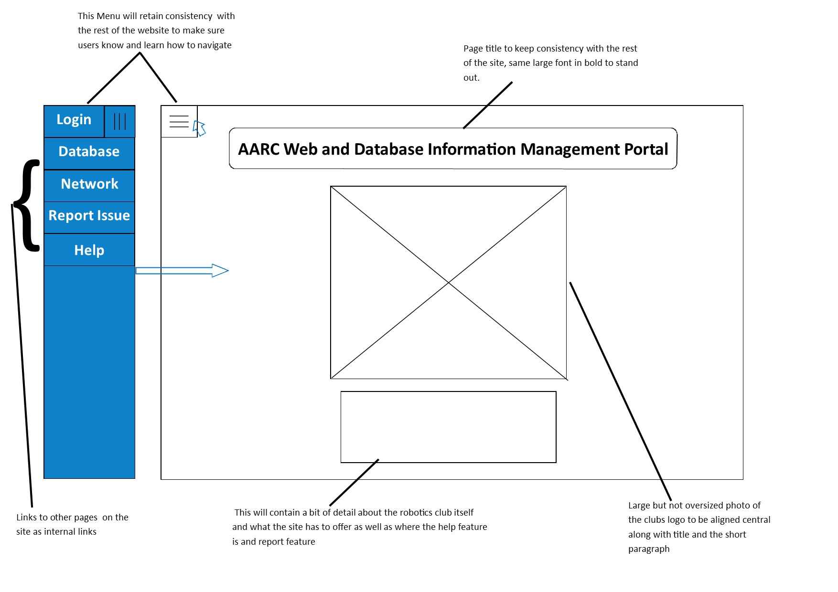



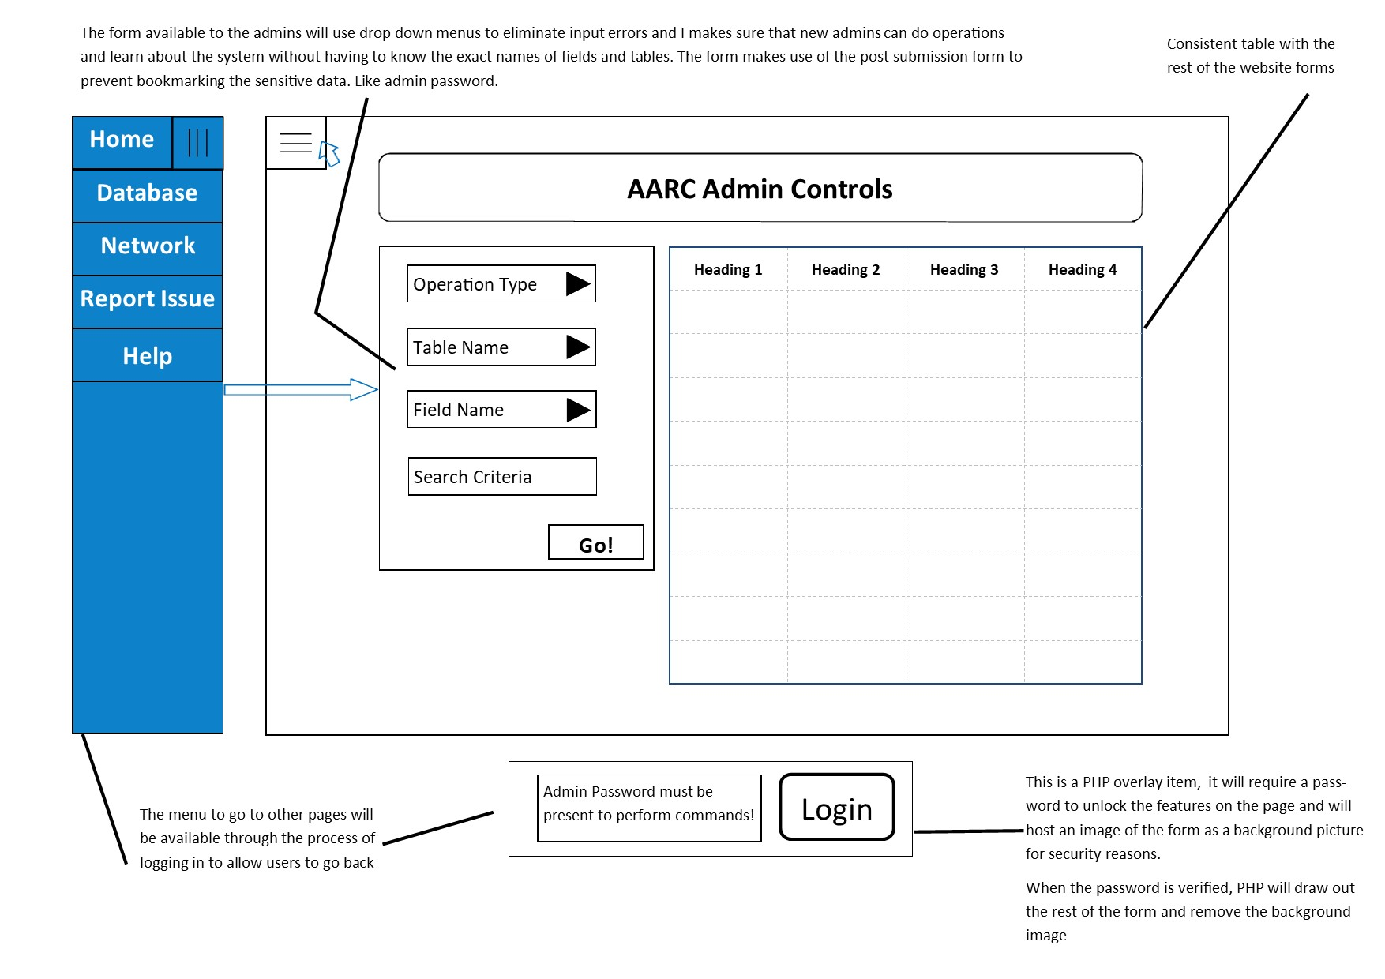





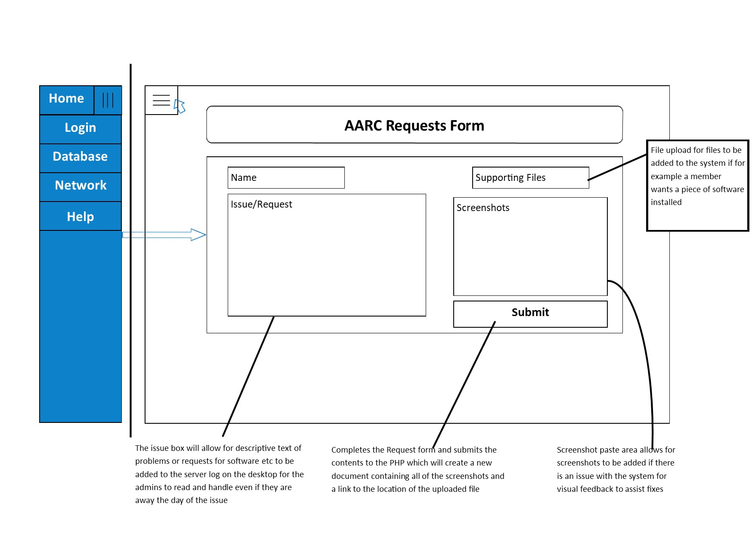



# Program and Data Structures

### Website Navigation Structure

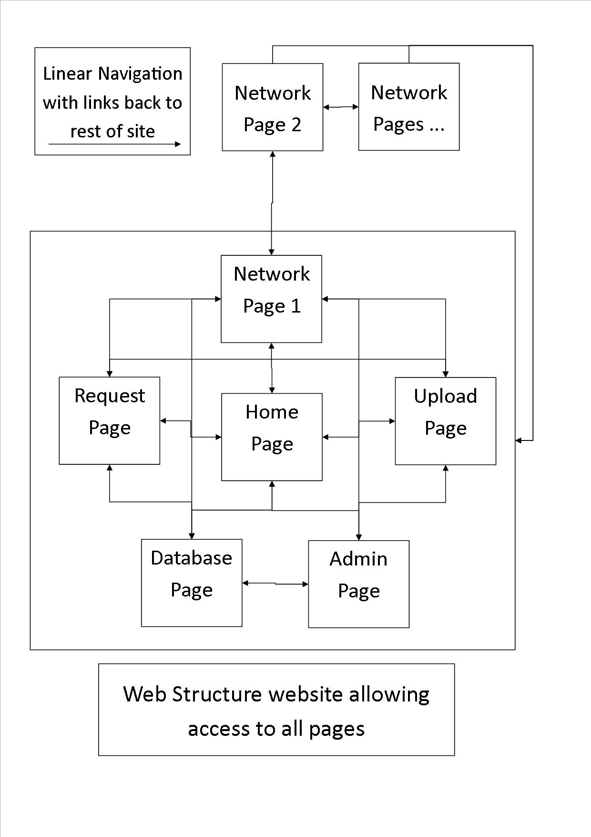

## 

## System data flow diagrams

### Web to PHP data flow

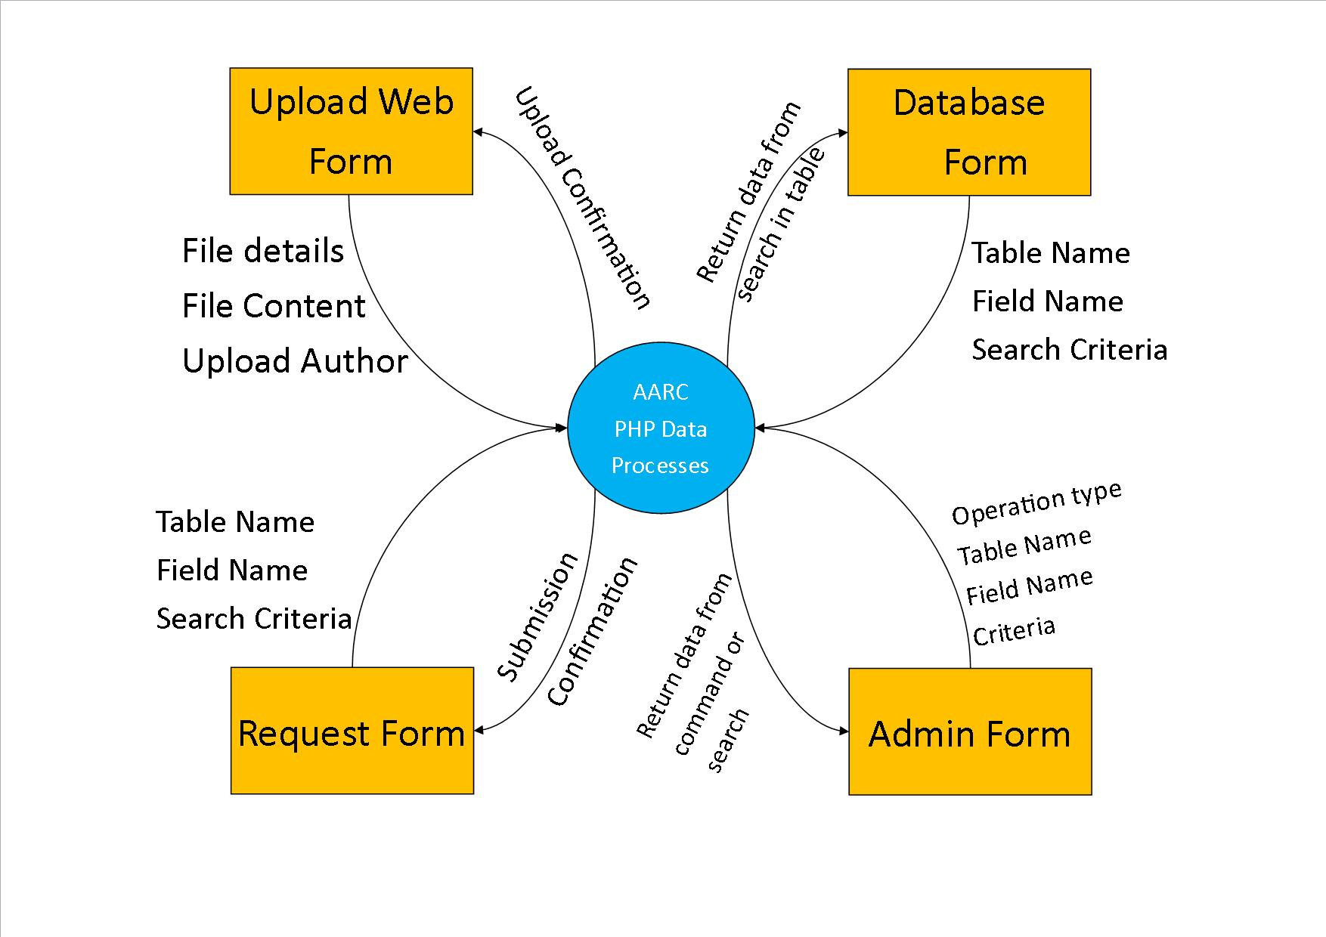

### PHP to MySQL data flow

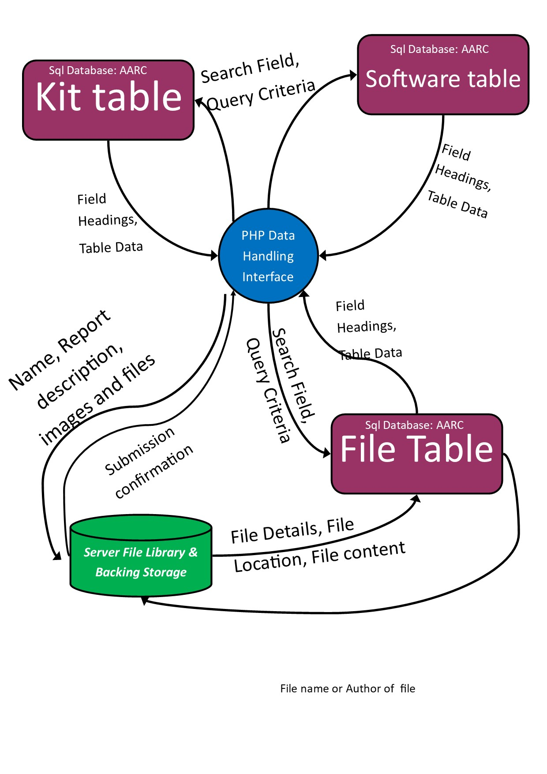

## Data Structures

Validation can take place in 3 ways; by JavaScript on the client side, SQL on fields which feedbacks through PHP or PHP validation which is more of a waste of time as SQL will validate anyway. However there would be a need to handle SQL Errors if the data isn’t validated so using JavaScript, a html form can have client side validation and that would mean that only internal SQL errors are needed to be accounted for.

The database is being cross reference and tested with Microsoft access as it’s a powerful tool to help validate inouts and able types. Any created tables are t

### SQL Data Dictionary ResourceT

|  |  |  |  |  |  |  |
| --- | --- | --- | --- | --- | --- | --- |
| Field | Type | P/F Key | Format | Auto Increment | Required | Default Value |
| TypeID | VARCHAR(15) | PK | 3 characters of Name & 4 numbers | - | Yes |  |
| Name | VARCHAR(30) | - | - | - | Yes |  |
| Location | VARCHAR(255) | - | - | - | Yes |  |
| FileSize | INTEGER | No | ###KB | - | No |  |
| Filetype | VARCHAR(8) | No | .### (.exe) | - | No |  |

### SQL Data Dictionary InventoryT

|  |  |  |  |  |  |  |
| --- | --- | --- | --- | --- | --- | --- |
| Field | Type | P/F Key | Format | Auto Increment | Required | Default Value |
| ID | INTEGER | PK | - | Yes | Yes |  |
| Qty | INTEGER | - | - | - | Yes | 1 |
| Date | INTEGER | - | Short date – (09/06/17) | - | Yes | (Today’s Date) |
| TypeID | VARCHAR(15) | FK | From Resource Table | - | Yes |  |
| CheckID | VARCHAR(15) | FK | From User Table | - | Yes |  |

### SQL Data Dictionary CheckerT

|  |  |  |  |  |  |  |
| --- | --- | --- | --- | --- | --- | --- |
| Field | Type | P/F Key | Format | Auto Increment | Required | Default Value |
| CheckID | VARCHAR(15) | PK | 2 Name Chars & 2 Numbers | - | Yes |  |
| UserID | VARCHAR(30) | FK | - | - | Yes |  |

### SQL Data Dictionary UserT

|  |  |  |  |  |  |  |
| --- | --- | --- | --- | --- | --- | --- |
| Field | Type | P/F Key | Format | Auto Increment | Required | Default Value |
| UserID | Integer | PK | - | Yes | Yes |  |
| MemberName | VARCHAR(30) | - | - | - | Yes |  |
| Username | VARCHAR(30) | - | - | - | Yes |  |
| Password | VARCHAR(30) | - | *** Mask | - | Yes | Password1 |
| Privilege | Yes/No | - | Yes/No | - | Yes |  |

## 

### SQL Commands used:

## PHP Data Processes

Page Start Terminators are when the page is loaded

***Report Page Flowchart***

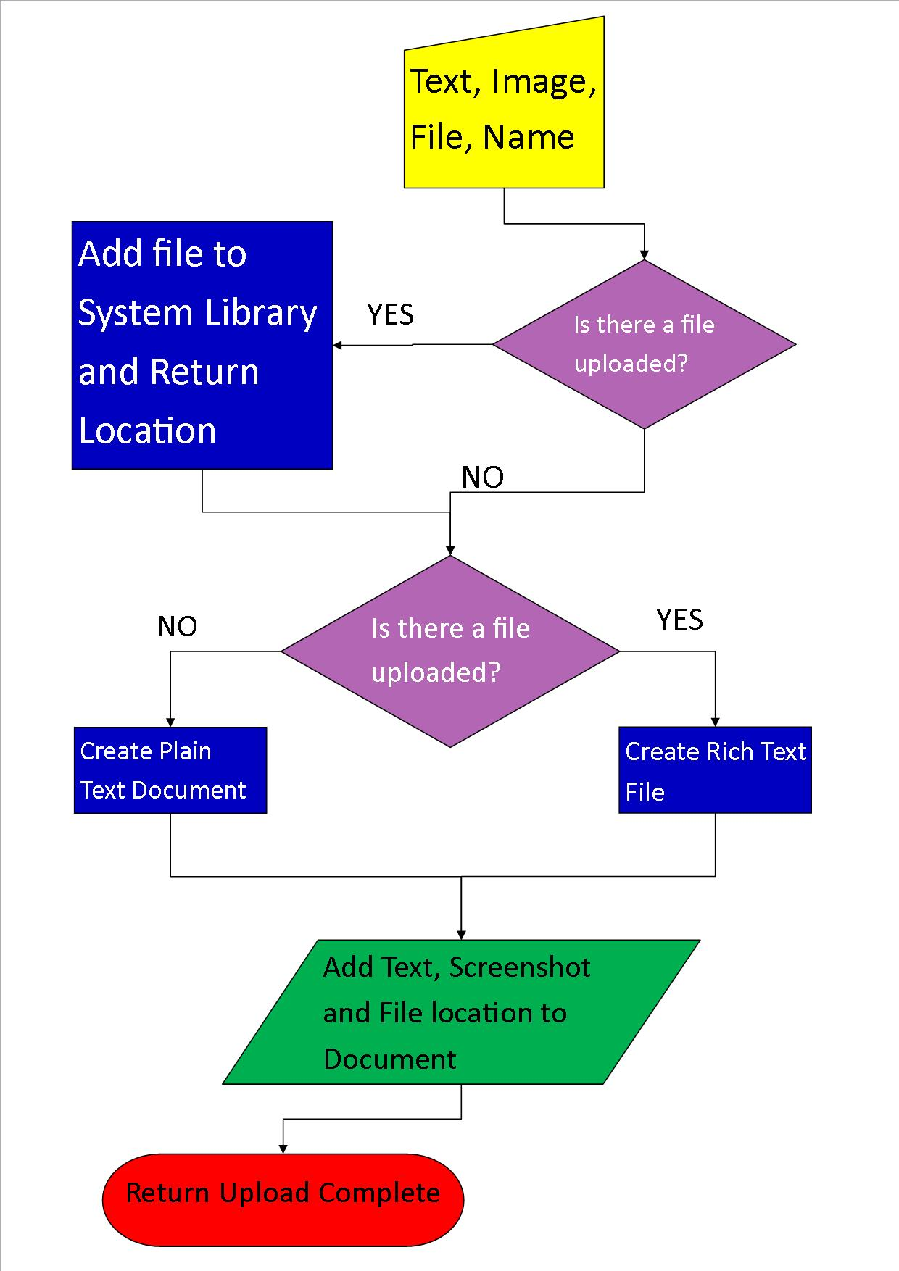

***Upload Page Flowchart***

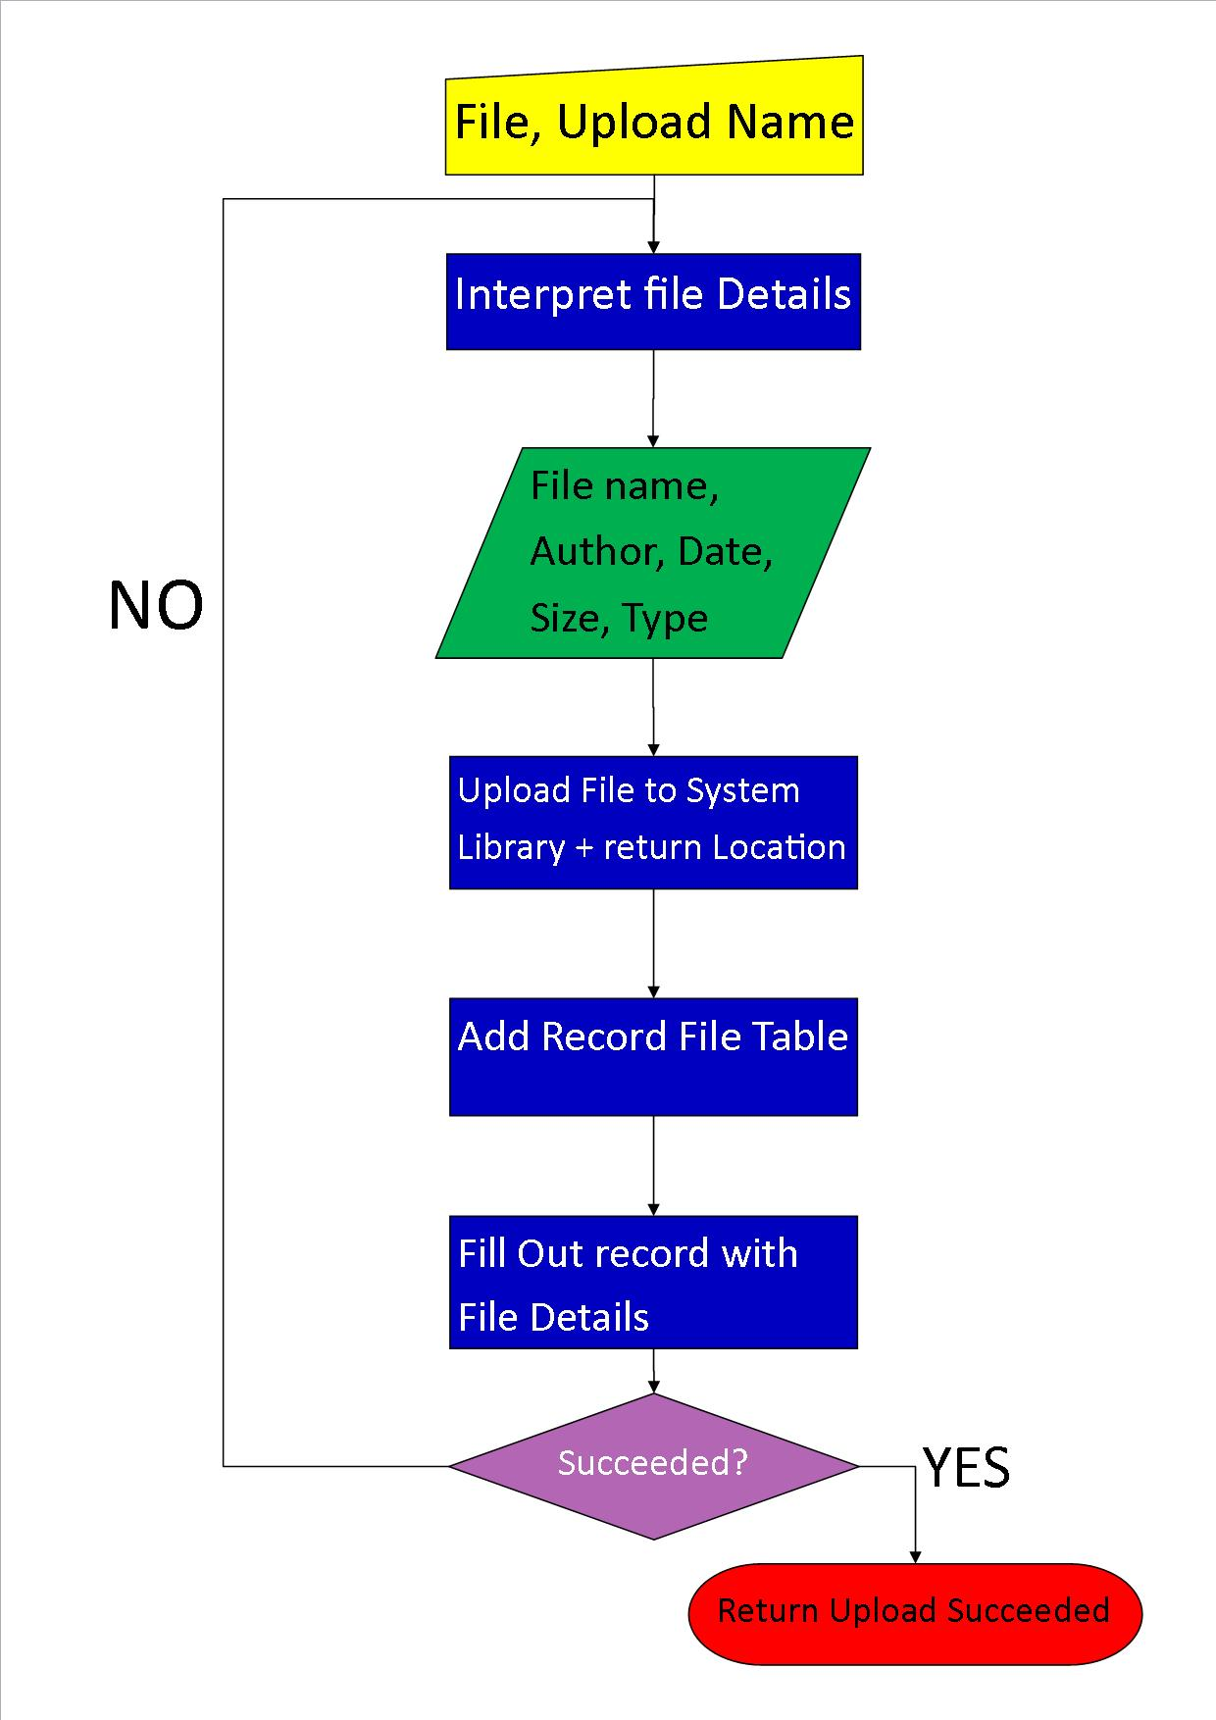

***Admin Page Flowchart***

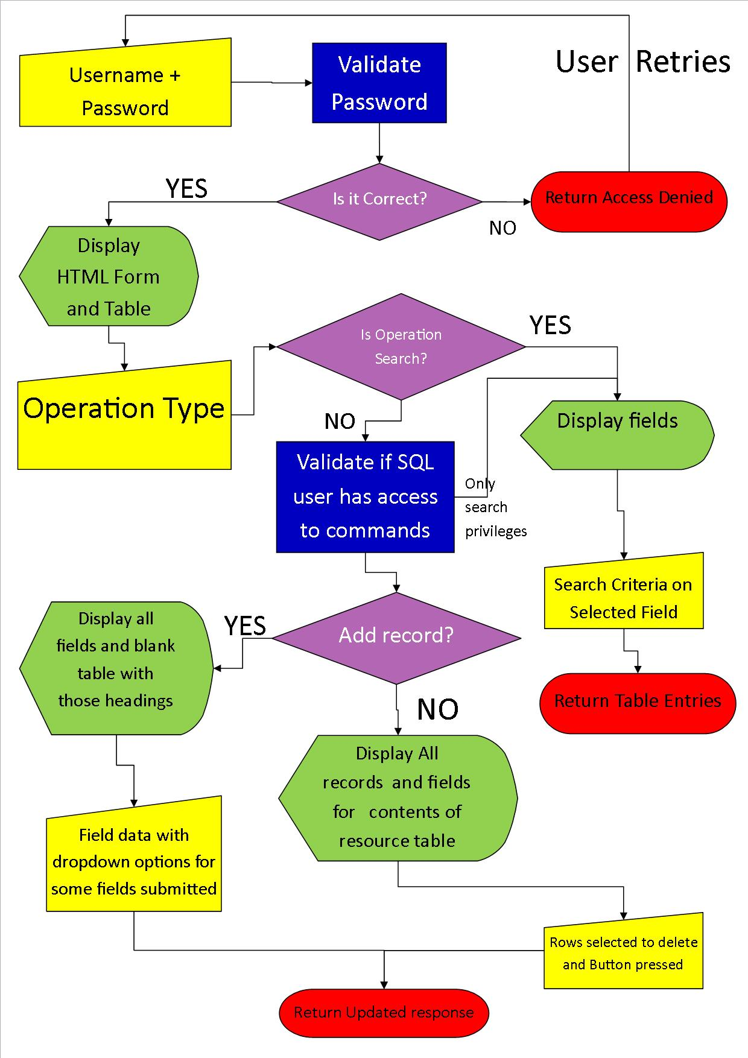

# Implementation

## Access & SQL Tests:

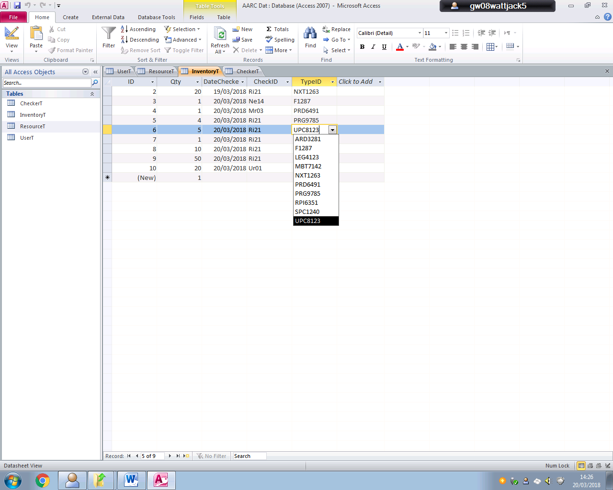 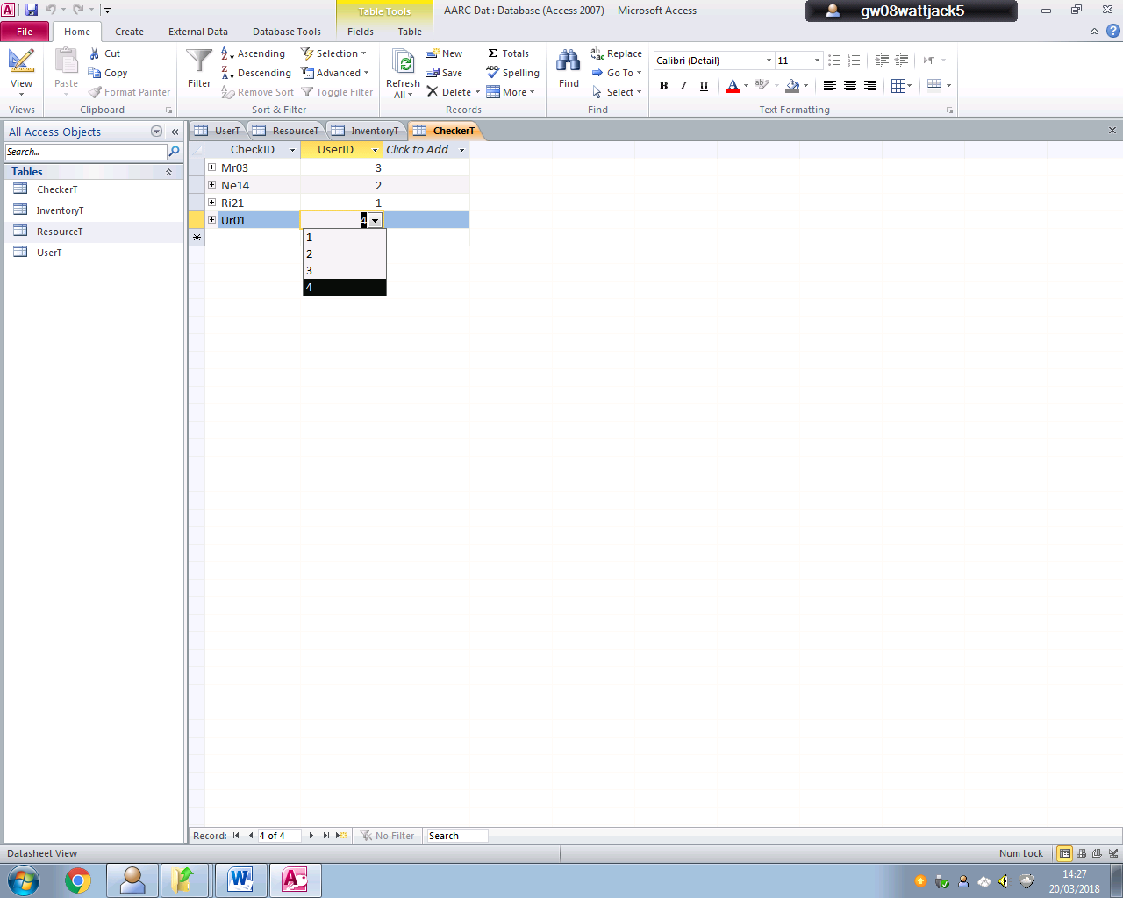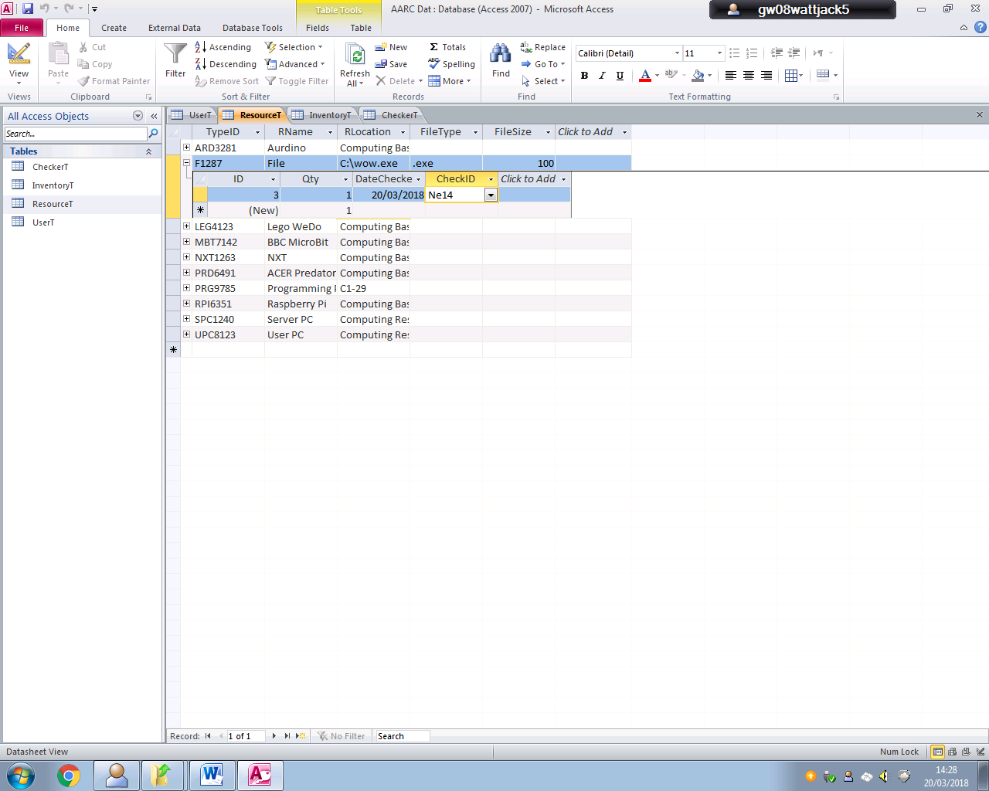

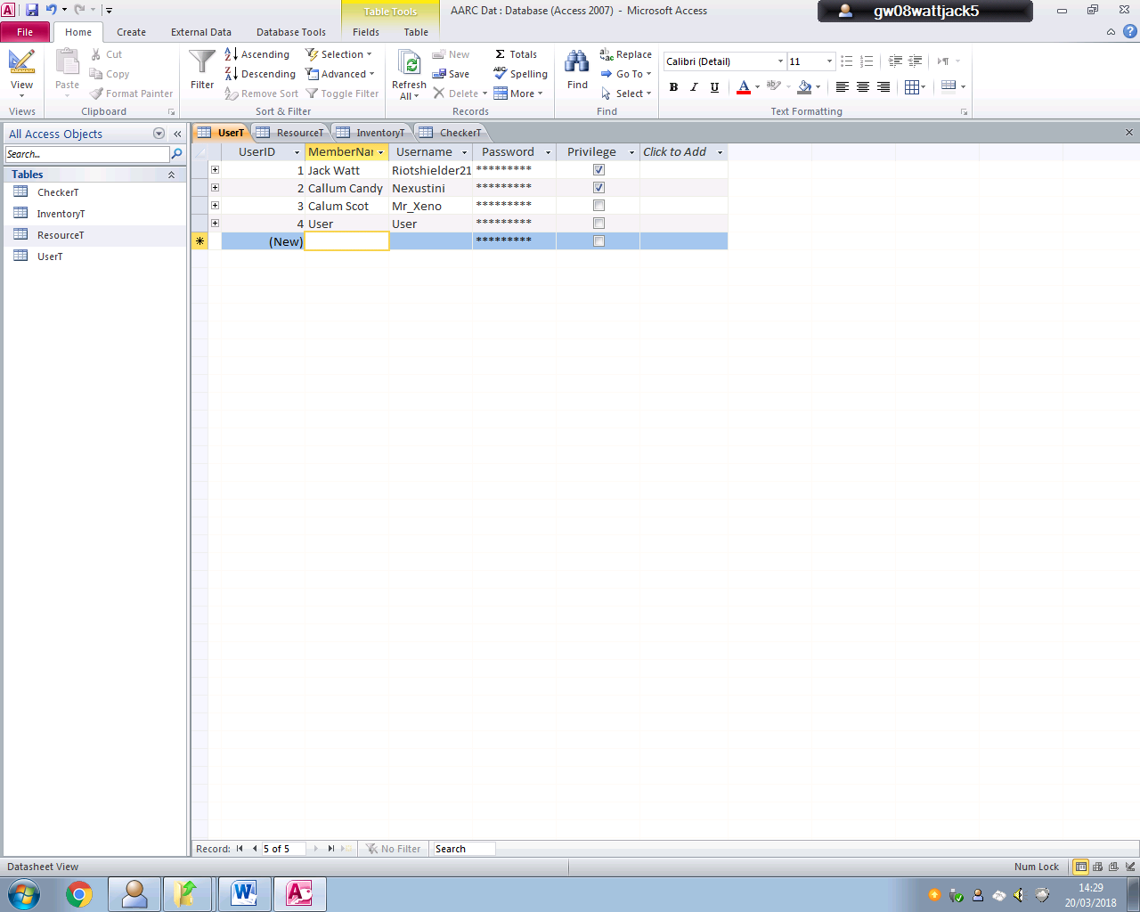

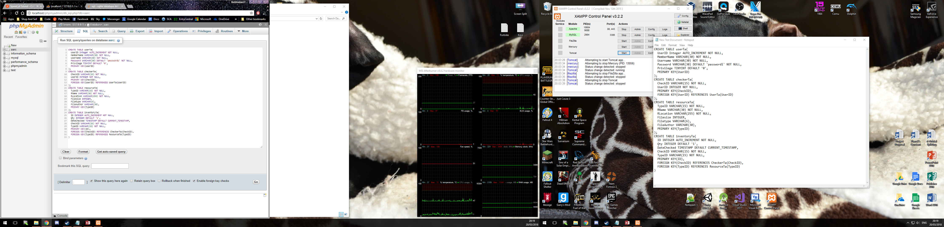

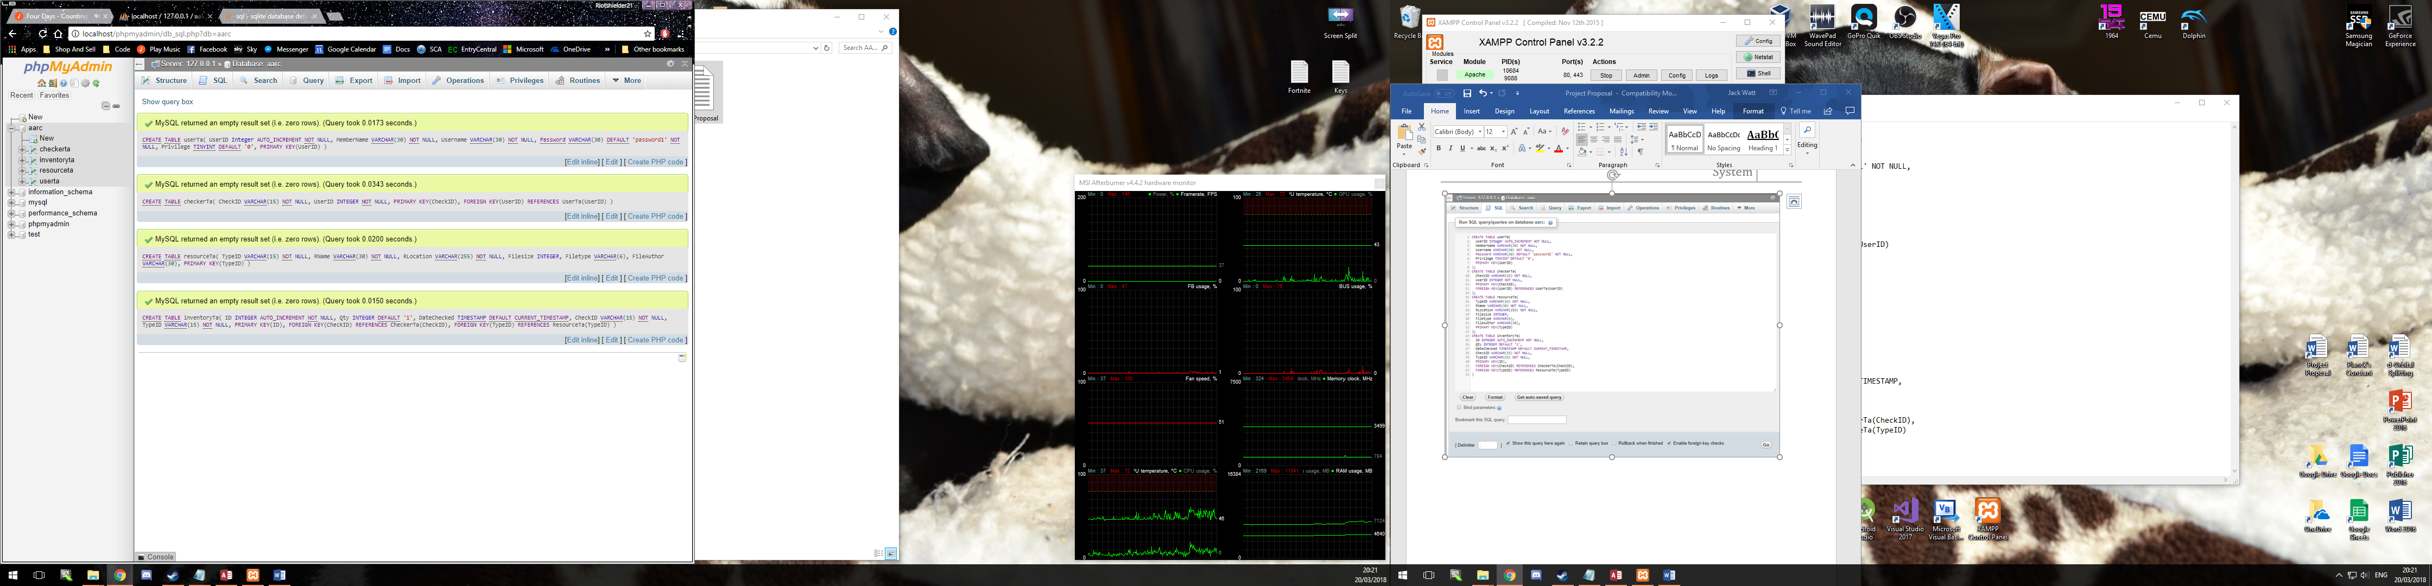

SQL Change Log;

1. Datechecked field of Inventoryta table is now of type Date rather than timestamp. And the default value will be set by the systems php when an upload is created

## Appendix:

N:\Database3.accdb 19 March 2018

Table: CheckerT Page: 1

**Properties**

AlternateBackShade: 95 AlternateBackThemeColorI 1

AlternateBackTint: 100 BackShade: 100

BackTint: 100 DatasheetForeThemeColor 0

DatasheetGridlinesThemeC 3 DateCreated: 19/03/2018 10:48:18

DefaultView: 2 DisplayViewsOnSharePoint 1

FilterOnLoad: False GUID: {guid {95D8B313-3CDD-

4508-A81A-

HideNewField: False LastUpdated: 19/03/2018 11:19:06

NameMap: Long binary data OrderByOn: False

OrderByOnLoad: True Orientation: Left-to-Right

PublishToWeb: 1 ReadOnlyWhenDisconnecte False

RecordCount: 0 ThemeFontIndex: 1

TotalsRow: False Updatable: True

**Columns**

Name Type Size

CheckID Text 15

AggregateType: -1

AllowZeroLength: True

AppendOnly: False

Attributes: Variable Length

CollatingOrder: General

ColumnHidden: False

ColumnOrder: Default

ColumnWidth: Default

CurrencyLCID: 0

DataUpdatable: False

DisplayControl: Text Box

GUID: {guid {FC886265-8F0A-4F50-ADED-5FC74FEAF6B6}}

IMEMode: 0

IMESentenceMode: 3

OrdinalPosition: 0

Required: True

ResultType: 0

SourceField: CheckID

SourceTable: CheckerT

TextAlign: General

UnicodeCompression: False

UserID Long Integer 4

AggregateType: -1

AllowZeroLength: False

AppendOnly: False

Attributes: Fixed Size

CollatingOrder: General

ColumnHidden: False

ColumnOrder: Default

ColumnWidth: Default

CurrencyLCID: 0

DataUpdatable: False

DecimalPlaces: Auto

DisplayControl: Text Box

GUID: {guid {8F0F724C-5311-4275-AB48-91437BB528F4}}

OrdinalPosition: 1

N:\Database3.accdb 19 March 2018

Table: CheckerT Page: 2

Required: True

ResultType: 0

SourceField: UserID

SourceTable: CheckerT

TextAlign: General

**Relationships**

**CheckerTInventoryT**

**CheckerT** **InventoryT**

CheckID 1  CheckID

Attributes: Enforced

RelationshipType: One-To-Many

**UserTCheckerT**

**UserT** **CheckerT**

UserID 1 1 UserID

Attributes: Unique, Enforced

RelationshipType: One-To-One

**Table Indexes**

Name Number of Fields

PrimaryKey 1

Clustered: False

DistinctCount: 0

Foreign: False

IgnoreNulls: False

Name: PrimaryKey

Primary: True

Required: True

Unique: True

Fields:

CheckID Ascending

UserID 1

Clustered: False

DistinctCount: 0

Foreign: False

IgnoreNulls: False

Name: UserID

Primary: False

Required: False

Unique: True

Fields:

UserID Ascending

UserTCheckerT 1

Clustered: False

DistinctCount: 0

Foreign: True

N:\Database3.accdb 19 March 2018

Table: CheckerT Page: 3

IgnoreNulls: False

Name: UserTCheckerT

Primary: False

Required: False

Unique: True

Fields:

UserID Ascending

**User Permissions**

admin Delete, Read Permissions, Set Permissions, Change Owner, Read Definition,

Write Definition, Read Data, Insert Data, Update Data, Delete Data

**Group Permissions**

Admins Delete, Read Permissions, Set Permissions, Change Owner, Read Definition,

Write Definition, Read Data, Insert Data, Update Data, Delete Data

Users Delete, Read Permissions, Set Permissions, Change Owner, Read Definition,

Write Definition, Read Data, Insert Data, Update Data, Delete Data

N:\Database3.accdb 19 March 2018

Table: CheckerT Page: 1

**Properties**

AlternateBackShade: 95 AlternateBackThemeColorI 1

AlternateBackTint: 100 BackShade: 100

BackTint: 100 DatasheetForeThemeColor 0

DatasheetGridlinesThemeC 3 DateCreated: 19/03/2018 10:48:18

DefaultView: 2 DisplayViewsOnSharePoint 1

FilterOnLoad: False GUID: {guid {95D8B313-3CDD-

4508-A81A-

HideNewField: False LastUpdated: 19/03/2018 11:19:06

NameMap: Long binary data OrderByOn: False

OrderByOnLoad: True Orientation: Left-to-Right

PublishToWeb: 1 ReadOnlyWhenDisconnecte False

RecordCount: 0 ThemeFontIndex: 1

TotalsRow: False Updatable: True

**Columns**

Name Type Size

CheckID Text 15

AggregateType: -1

AllowZeroLength: True

AppendOnly: False

Attributes: Variable Length

CollatingOrder: General

ColumnHidden: False

ColumnOrder: Default

ColumnWidth: Default

CurrencyLCID: 0

DataUpdatable: False

DisplayControl: Text Box

GUID: {guid {FC886265-8F0A-4F50-ADED-5FC74FEAF6B6}}

IMEMode: 0

IMESentenceMode: 3

OrdinalPosition: 0

Required: True

ResultType: 0

SourceField: CheckID

SourceTable: CheckerT

TextAlign: General

UnicodeCompression: False

UserID Long Integer 4

AggregateType: -1

AllowZeroLength: False

AppendOnly: False

Attributes: Fixed Size

CollatingOrder: General

ColumnHidden: False

ColumnOrder: Default

ColumnWidth: Default

CurrencyLCID: 0

DataUpdatable: False

DecimalPlaces: Auto

DisplayControl: Text Box

GUID: {guid {8F0F724C-5311-4275-AB48-91437BB528F4}}

OrdinalPosition: 1

N:\Database3.accdb 19 March 2018

Table: CheckerT Page: 2

Required: True

ResultType: 0

SourceField: UserID

SourceTable: CheckerT

TextAlign: General

**Relationships**

**CheckerTInventoryT**

**CheckerT** **InventoryT**

CheckID 1  CheckID

Attributes: Enforced

RelationshipType: One-To-Many

**UserTCheckerT**

**UserT** **CheckerT**

UserID 1 1 UserID

Attributes: Unique, Enforced

RelationshipType: One-To-One

**Table Indexes**

Name Number of Fields

PrimaryKey 1

Clustered: False

DistinctCount: 0

Foreign: False

IgnoreNulls: False

Name: PrimaryKey

Primary: True

Required: True

Unique: True

Fields:

CheckID Ascending

UserID 1

Clustered: False

DistinctCount: 0

Foreign: False

IgnoreNulls: False

Name: UserID

Primary: False

Required: False

Unique: True

Fields:

UserID Ascending

UserTCheckerT 1

Clustered: False

DistinctCount: 0

Foreign: True

N:\Database3.accdb 19 March 2018

Table: CheckerT Page: 3

IgnoreNulls: False

Name: UserTCheckerT

Primary: False

Required: False

Unique: True

Fields:

UserID Ascending

**User Permissions**

admin Delete, Read Permissions, Set Permissions, Change Owner, Read Definition,

Write Definition, Read Data, Insert Data, Update Data, Delete Data

**Group Permissions**

Admins Delete, Read Permissions, Set Permissions, Change Owner, Read Definition,

Write Definition, Read Data, Insert Data, Update Data, Delete Data

Users Delete, Read Permissions, Set Permissions, Change Owner, Read Definition,

Write Definition, Read Data, Insert Data, Update Data, Delete Data

N:\Database3.accdb 19 March 2018

Table: InventoryT Page: 4

**Properties**

AlternateBackShade: 95 AlternateBackThemeColorI 1

AlternateBackTint: 100 BackShade: 100

BackTint: 100 DatasheetForeThemeColor 0

DatasheetGridlinesThemeC 3 DateCreated: 19/03/2018 10:38:30

DefaultView: 2 DisplayViewsOnSharePoint 1

FilterOnLoad: False GUID: {guid {2C8869C7-38F7-

4CC1-80E2-21B23DD23CE5}}

HideNewField: False LastUpdated: 19/03/2018 11:45:45

NameMap: Long binary data OrderByOn: False

OrderByOnLoad: True Orientation: Left-to-Right

PublishToWeb: 1 ReadOnlyWhenDisconnecte False

RecordCount: 0 ThemeFontIndex: 1

TotalsRow: False Updatable: True

**Columns**

Name Type Size

ID Long Integer 4

AggregateType: -1

AllowZeroLength: False

AppendOnly: False

Attributes: Fixed Size, Auto-Increment

CollatingOrder: General

ColumnHidden: False

ColumnOrder: Default

ColumnWidth: Default

CurrencyLCID: 0

DataUpdatable: False

GUID: {guid {D71841D0-D082-486C-9462-D54D41C61603}}

OrdinalPosition: 0

Required: False

ResultType: 0

SourceField: ID

SourceTable: InventoryT

TextAlign: General

Qty Integer 2

AggregateType: -1

AllowZeroLength: False

AppendOnly: False

Attributes: Fixed Size

CollatingOrder: General

ColumnHidden: False

ColumnOrder: Default

ColumnWidth: Default

CurrencyLCID: 0

DataUpdatable: False

DecimalPlaces: Auto

DefaultValue: 1

DisplayControl: Text Box

GUID: {guid {26EC3282-1CE5-4432-A097-C10D1F331F07}}

OrdinalPosition: 1

Required: False

ResultType: 0

SourceField: Qty

N:\Database3.accdb 19 March 2018

Table: InventoryT Page: 5

SourceTable: InventoryT

TextAlign: General

DateChecked Date/Time 8

AggregateType: -1

AllowZeroLength: False

AppendOnly: False

Attributes: Fixed Size

CollatingOrder: General

ColumnHidden: False

ColumnOrder: Default

ColumnWidth: Default

CurrencyLCID: 0

DataUpdatable: False

Format: Short Date

GUID: {guid {D5FDC06F-AAF6-4F4A-B382-3B67A2D31722}}

IMEMode: 0

IMESentenceMode: 3

OrdinalPosition: 2

Required: True

ResultType: 0

ShowDatePicker: For dates

SourceField: DateChecked

SourceTable: InventoryT

TextAlign: General

CheckID Text 15

AggregateType: -1

AllowZeroLength: True

AppendOnly: False

Attributes: Variable Length

CollatingOrder: General

ColumnHidden: False

ColumnOrder: Default

ColumnWidth: Default

CurrencyLCID: 0

DataUpdatable: False

DisplayControl: Text Box

GUID: {guid {1893F57E-72A4-4C16-AAC3-14AEF60645BE}}

IMEMode: 0

IMESentenceMode: 3

OrdinalPosition: 3

Required: True

ResultType: 0

SourceField: CheckID

SourceTable: InventoryT

TextAlign: General

UnicodeCompression: True

TypeID Text 15

AggregateType: -1

AllowZeroLength: True

AppendOnly: False

Attributes: Variable Length

CollatingOrder: General

ColumnHidden: False

ColumnOrder: Default

ColumnWidth: Default

CurrencyLCID: 0

DataUpdatable: False

N:\Database3.accdb 19 March 2018

Table: InventoryT Page: 6

DisplayControl: Text Box

GUID: {guid {D7E6F7EB-A6AB-46E4-96DF-DBA5E130BA49}}

IMEMode: 0

IMESentenceMode: 3

OrdinalPosition: 4

Required: True

ResultType: 0

SourceField: TypeID

SourceTable: InventoryT

TextAlign: General

UnicodeCompression: True

**Relationships**

**CheckerTInventoryT**

**CheckerT** **InventoryT**

CheckID 1  CheckID

Attributes: Enforced

RelationshipType: One-To-Many

**ResourceTInventoryT**

**ResourceT** **InventoryT**

TypeID 1  TypeID

Attributes: Enforced

RelationshipType: One-To-Many

**Table Indexes**

Name Number of Fields

CheckerTInventoryT 1

Clustered: False

DistinctCount: 0

Foreign: True

IgnoreNulls: False

Name: CheckerTInventoryT

Primary: False

Required: False

Unique: False

Fields:

CheckID Ascending

CheckID 1

Clustered: False

DistinctCount: 0

Foreign: False

IgnoreNulls: False

Name: CheckID

Primary: False

Required: False

Unique: False

N:\Database3.accdb 19 March 2018

Table: InventoryT Page: 7

Fields:

CheckID Ascending

PrimaryKey 1

Clustered: False

DistinctCount: 0

Foreign: False

IgnoreNulls: False

Name: PrimaryKey

Primary: True

Required: True

Unique: True

Fields:

ID Ascending

ResourceTInventoryT 1

Clustered: False

DistinctCount: 0

Foreign: True

IgnoreNulls: False

Name: ResourceTInventoryT

Primary: False

Required: False

Unique: False

Fields:

TypeID Ascending

TypeID 1

Clustered: False

DistinctCount: 0

Foreign: False

IgnoreNulls: False

Name: TypeID

Primary: False

Required: False

Unique: False

Fields:

TypeID Ascending

**User Permissions**

admin Delete, Read Permissions, Set Permissions, Change Owner, Read Definition,

Write Definition, Read Data, Insert Data, Update Data, Delete Data

**Group Permissions**

Admins Delete, Read Permissions, Set Permissions, Change Owner, Read Definition,

Write Definition, Read Data, Insert Data, Update Data, Delete Data

Users Delete, Read Permissions, Set Permissions, Change Owner, Read Definition,

Write Definition, Read Data, Insert Data, Update Data, Delete Data

N:\Database3.accdb 19 March 2018

Table: ResourceT Page: 8

**Properties**

AlternateBackShade: 95 AlternateBackThemeColorI 1

AlternateBackTint: 100 BackShade: 100

BackTint: 100 DatasheetForeThemeColor 0

DatasheetGridlinesThemeC 3 DateCreated: 19/03/2018 10:36:02

DefaultView: 2 DisplayViewsOnSharePoint 1

FilterOnLoad: False GUID: {guid {05F3DB14-4F15-

4ED7-90B8-09FA20DE5C4A}}

HideNewField: False LastUpdated: 19/03/2018 11:07:19

NameMap: Long binary data OrderByOn: False

OrderByOnLoad: True Orientation: Left-to-Right

PublishToWeb: 1 ReadOnlyWhenDisconnecte False

RecordCount: 0 ThemeFontIndex: 1

TotalsRow: False Updatable: True

**Columns**

Name Type Size

TypeID Text 15

AggregateType: -1

AllowZeroLength: True

AppendOnly: False

Attributes: Variable Length

CollatingOrder: General

ColumnHidden: False

ColumnOrder: Default

ColumnWidth: Default

CurrencyLCID: 0

DataUpdatable: False

DisplayControl: Text Box

GUID: {guid {6763E0EB-2E5E-486E-A2F4-7FE833627F6F}}

IMEMode: 0

IMESentenceMode: 3

OrdinalPosition: 0

Required: True

ResultType: 0

SourceField: TypeID

SourceTable: ResourceT

TextAlign: General

UnicodeCompression: False

RName Text 30

AggregateType: -1

AllowZeroLength: True

AppendOnly: False

Attributes: Variable Length

CollatingOrder: General

ColumnHidden: False

ColumnOrder: Default

ColumnWidth: Default

CurrencyLCID: 0

DataUpdatable: False

DisplayControl: Text Box

GUID: {guid {54F49E36-C49B-4C0F-9340-AC3BDCD5BD6E}}

IMEMode: 0

IMESentenceMode: 3

N:\Database3.accdb 19 March 2018

Table: ResourceT Page: 9

OrdinalPosition: 1

Required: True

ResultType: 0

SourceField: RName

SourceTable: ResourceT

TextAlign: General

UnicodeCompression: True

RLocation Text 255

AggregateType: -1

AllowZeroLength: True

AppendOnly: False

Attributes: Variable Length

CollatingOrder: General

ColumnHidden: False

ColumnOrder: Default

ColumnWidth: Default

CurrencyLCID: 0

DataUpdatable: False

DisplayControl: Text Box

GUID: {guid {9911E964-8ECE-434C-B658-0CB2B2376C79}}

IMEMode: 0

IMESentenceMode: 3

OrdinalPosition: 2

Required: True

ResultType: 0

SourceField: RLocation

SourceTable: ResourceT

TextAlign: General

UnicodeCompression: True

FileType Text 8

AggregateType: -1

AllowZeroLength: True

AppendOnly: False

Attributes: Variable Length

CollatingOrder: General

ColumnHidden: False

ColumnOrder: Default

ColumnWidth: Default

CurrencyLCID: 0

DataUpdatable: False

DisplayControl: Text Box

GUID: {guid {CC190700-05F4-4E14-84CF-9AB632C42B54}}

IMEMode: 0

IMESentenceMode: 3

OrdinalPosition: 3

Required: False

ResultType: 0

SourceField: FileType

SourceTable: ResourceT

TextAlign: General

UnicodeCompression: True

FileSize Long Integer 4

AggregateType: -1

AllowZeroLength: False

AppendOnly: False

Attributes: Fixed Size

CollatingOrder: General

N:\Database3.accdb 19 March 2018

Table: ResourceT Page: 10

ColumnHidden: False

ColumnOrder: Default

ColumnWidth: Default

CurrencyLCID: 0

DataUpdatable: False

DecimalPlaces: Auto

DisplayControl: Text Box

GUID: {guid {27CFDA5A-A721-47C4-8645-BE7F38004B6E}}

OrdinalPosition: 4

Required: False

ResultType: 0

SourceField: FileSize

SourceTable: ResourceT

TextAlign: General

**Relationships**

**ResourceTInventoryT**

**ResourceT** **InventoryT**

TypeID 1  TypeID

Attributes: Enforced

RelationshipType: One-To-Many

**Table Indexes**

Name Number of Fields

PrimaryKey 1

Clustered: False

DistinctCount: 0

Foreign: False

IgnoreNulls: False

Name: PrimaryKey

Primary: True

Required: True

Unique: True

Fields:

TypeID Ascending

**User Permissions**

admin Delete, Read Permissions, Set Permissions, Change Owner, Read Definition,

Write Definition, Read Data, Insert Data, Update Data, Delete Data

**Group Permissions**

Admins Delete, Read Permissions, Set Permissions, Change Owner, Read Definition,

Write Definition, Read Data, Insert Data, Update Data, Delete Data

Users Delete, Read Permissions, Set Permissions, Change Owner, Read Definition,

Write Definition, Read Data, Insert Data, Update Data, Delete Data

N:\Database3.accdb 19 March 2018

Table: UserT Page: 11

**Properties**

AlternateBackShade: 95 AlternateBackThemeColorI 1

AlternateBackTint: 100 BackShade: 100

BackTint: 100 DatasheetForeThemeColor 0

DatasheetGridlinesThemeC 3 DateCreated: 19/03/2018 11:02:37

DefaultView: 2 DisplayViewsOnSharePoint 1

FilterOnLoad: False GUID: {guid {503FD671-1207-42F1-

A523-446EF7F79518}}

HideNewField: False LastUpdated: 19/03/2018 11:45:47

NameMap: Long binary data OrderByOn: False

OrderByOnLoad: True Orientation: Left-to-Right

PublishToWeb: 1 ReadOnlyWhenDisconnecte False

RecordCount: 0 ThemeFontIndex: 1

TotalsRow: False Updatable: True

**Columns**

Name Type Size

UserID Long Integer 4

AggregateType: -1

AllowZeroLength: False

AppendOnly: False

Attributes: Fixed Size, Auto-Increment

CollatingOrder: General

ColumnHidden: False

ColumnOrder: Default

ColumnWidth: Default

CurrencyLCID: 0

DataUpdatable: False

GUID: {guid {4054CFF1-0402-4D74-9675-D7189303BE61}}

OrdinalPosition: 0

Required: False

ResultType: 0

SourceField: UserID

SourceTable: UserT

TextAlign: General

MemberName Text 30

AggregateType: -1

AllowZeroLength: True

AppendOnly: False

Attributes: Variable Length

CollatingOrder: General

ColumnHidden: False

ColumnOrder: Default

ColumnWidth: Default

CurrencyLCID: 0

DataUpdatable: False

DisplayControl: Text Box

GUID: {guid {1A2178BE-01D1-412F-9035-8FFE81C85379}}

IMEMode: 0

IMESentenceMode: 3

OrdinalPosition: 1

Required: True

ResultType: 0

SourceField: MemberName

N:\Database3.accdb 19 March 2018

Table: UserT Page: 12

SourceTable: UserT

TextAlign: General

UnicodeCompression: True

Username Text 30

AggregateType: -1

AllowZeroLength: True

AppendOnly: False

Attributes: Variable Length

CollatingOrder: General

ColumnHidden: False

ColumnOrder: Default

ColumnWidth: Default

CurrencyLCID: 0

DataUpdatable: False

DisplayControl: Text Box

GUID: {guid {D657151C-8114-474D-8297-6595AD2EB721}}

IMEMode: 0

IMESentenceMode: 3

OrdinalPosition: 2

Required: True

ResultType: 0

SourceField: Username

SourceTable: UserT

TextAlign: General

UnicodeCompression: True

Password Text 30

AggregateType: -1

AllowZeroLength: True

AppendOnly: False

Attributes: Variable Length

CollatingOrder: General

ColumnHidden: False

ColumnOrder: Default

ColumnWidth: Default

CurrencyLCID: 0

DataUpdatable: False

DefaultValue: "Password1"

DisplayControl: Text Box

GUID: {guid {DA084A51-BC67-44A2-9C50-917318ECA378}}

IMEMode: 0

IMESentenceMode: 3

InputMask: \*

OrdinalPosition: 3

Required: True

ResultType: 0

SourceField: Password

SourceTable: UserT

TextAlign: General

UnicodeCompression: True

Privilege Yes/No 1

AggregateType: -1

AllowZeroLength: False

AppendOnly: False

Attributes: Fixed Size

CollatingOrder: General

ColumnHidden: False

ColumnOrder: Default

N:\Database3.accdb 19 March 2018

Table: UserT Page: 13

ColumnWidth: Default

CurrencyLCID: 0

DataUpdatable: False

DefaultValue: 0

DisplayControl: 106

Format: Yes/No

GUID: {guid {29F72F36-C53C-4E9C-89E8-7DF1F48760FD}}

OrdinalPosition: 4

Required: False

ResultType: 0

SourceField: Privilege

SourceTable: UserT

TextAlign: General

**Relationships**

**UserTCheckerT**

**UserT** **CheckerT**

UserID 1 1 UserID

Attributes: Unique, Enforced

RelationshipType: One-To-One

**Table Indexes**

Name Number of Fields

PrimaryKey 1

Clustered: False

DistinctCount: 0

Foreign: False

IgnoreNulls: False

Name: PrimaryKey

Primary: True

Required: True

Unique: True

Fields:

UserID Ascending

**User Permissions**

admin Delete, Read Permissions, Set Permissions, Change Owner, Read Definition,

Write Definition, Read Data, Insert Data, Update Data, Delete Data

**Group Permissions**

Admins Delete, Read Permissions, Set Permissions, Change Owner, Read Definition,

Write Definition, Read Data, Insert Data, Update Data, Delete Data

Users Delete, Read Permissions, Set Permissions, Change Owner, Read Definition,

Write Definition, Read Data, Insert Data, Update Data, Delete Data

N:\Database3.accdb 19 March 2018

Table: ResourceT Page: 8

**Properties**

AlternateBackShade: 95 AlternateBackThemeColorI 1

AlternateBackTint: 100 BackShade: 100

BackTint: 100 DatasheetForeThemeColor 0

DatasheetGridlinesThemeC 3 DateCreated: 19/03/2018 10:36:02

DefaultView: 2 DisplayViewsOnSharePoint 1

FilterOnLoad: False GUID: {guid {05F3DB14-4F15-

4ED7-90B8-09FA20DE5C4A}}

HideNewField: False LastUpdated: 19/03/2018 11:07:19

NameMap: Long binary data OrderByOn: False

OrderByOnLoad: True Orientation: Left-to-Right

PublishToWeb: 1 ReadOnlyWhenDisconnecte False

RecordCount: 0 ThemeFontIndex: 1

TotalsRow: False Updatable: True

**Columns**

Name Type Size

TypeID Text 15

AggregateType: -1

AllowZeroLength: True

AppendOnly: False

Attributes: Variable Length

CollatingOrder: General

ColumnHidden: False

ColumnOrder: Default

ColumnWidth: Default

CurrencyLCID: 0

DataUpdatable: False

DisplayControl: Text Box

GUID: {guid {6763E0EB-2E5E-486E-A2F4-7FE833627F6F}}

IMEMode: 0

IMESentenceMode: 3

OrdinalPosition: 0

Required: True

ResultType: 0

SourceField: TypeID

SourceTable: ResourceT

TextAlign: General

UnicodeCompression: False

RName Text 30

AggregateType: -1

AllowZeroLength: True

AppendOnly: False

Attributes: Variable Length

CollatingOrder: General

ColumnHidden: False

ColumnOrder: Default

ColumnWidth: Default

CurrencyLCID: 0

DataUpdatable: False

DisplayControl: Text Box

GUID: {guid {54F49E36-C49B-4C0F-9340-AC3BDCD5BD6E}}

IMEMode: 0

IMESentenceMode: 3

N:\Database3.accdb 19 March 2018

Table: ResourceT Page: 9

OrdinalPosition: 1

Required: True

ResultType: 0

SourceField: RName

SourceTable: ResourceT

TextAlign: General

UnicodeCompression: True

RLocation Text 255

AggregateType: -1

AllowZeroLength: True

AppendOnly: False

Attributes: Variable Length

CollatingOrder: General

ColumnHidden: False

ColumnOrder: Default

ColumnWidth: Default

CurrencyLCID: 0

DataUpdatable: False

DisplayControl: Text Box

GUID: {guid {9911E964-8ECE-434C-B658-0CB2B2376C79}}

IMEMode: 0

IMESentenceMode: 3

OrdinalPosition: 2

Required: True

ResultType: 0

SourceField: RLocation

SourceTable: ResourceT

TextAlign: General

UnicodeCompression: True

FileType Text 8

AggregateType: -1

AllowZeroLength: True

AppendOnly: False

Attributes: Variable Length

CollatingOrder: General

ColumnHidden: False

ColumnOrder: Default

ColumnWidth: Default

CurrencyLCID: 0

DataUpdatable: False

DisplayControl: Text Box

GUID: {guid {CC190700-05F4-4E14-84CF-9AB632C42B54}}

IMEMode: 0

IMESentenceMode: 3

OrdinalPosition: 3

Required: False

ResultType: 0

SourceField: FileType

SourceTable: ResourceT

TextAlign: General

UnicodeCompression: True

FileSize Long Integer 4

AggregateType: -1

AllowZeroLength: False

AppendOnly: False

Attributes: Fixed Size

CollatingOrder: General

N:\Database3.accdb 19 March 2018

Table: ResourceT Page: 10

ColumnHidden: False

ColumnOrder: Default

ColumnWidth: Default

CurrencyLCID: 0

DataUpdatable: False

DecimalPlaces: Auto

DisplayControl: Text Box

GUID: {guid {27CFDA5A-A721-47C4-8645-BE7F38004B6E}}

OrdinalPosition: 4

Required: False

ResultType: 0

SourceField: FileSize

SourceTable: ResourceT

TextAlign: General

**Relationships**

**ResourceTInventoryT**

**ResourceT** **InventoryT**

TypeID 1  TypeID

Attributes: Enforced

RelationshipType: One-To-Many

**Table Indexes**

Name Number of Fields

PrimaryKey 1

Clustered: False

DistinctCount: 0

Foreign: False

IgnoreNulls: False

Name: PrimaryKey

Primary: True

Required: True

Unique: True

Fields:

TypeID Ascending

**User Permissions**

admin Delete, Read Permissions, Set Permissions, Change Owner, Read Definition,

Write Definition, Read Data, Insert Data, Update Data, Delete Data

**Group Permissions**

Admins Delete, Read Permissions, Set Permissions, Change Owner, Read Definition,

Write Definition, Read Data, Insert Data, Update Data, Delete Data

Users Delete, Read Permissions, Set Permissions, Change Owner, Read Definition,

Write Definition, Read Data, Insert Data, Update Data, Delete Data

N:\Database3.accdb 19 March 2018

Table: UserT Page: 11

**Properties**

AlternateBackShade: 95 AlternateBackThemeColorI 1

AlternateBackTint: 100 BackShade: 100

BackTint: 100 DatasheetForeThemeColor 0

DatasheetGridlinesThemeC 3 DateCreated: 19/03/2018 11:02:37

DefaultView: 2 DisplayViewsOnSharePoint 1

FilterOnLoad: False GUID: {guid {503FD671-1207-42F1-

A523-446EF7F79518}}

HideNewField: False LastUpdated: 19/03/2018 11:45:47

NameMap: Long binary data OrderByOn: False

OrderByOnLoad: True Orientation: Left-to-Right

PublishToWeb: 1 ReadOnlyWhenDisconnecte False

RecordCount: 0 ThemeFontIndex: 1

TotalsRow: False Updatable: True

**Columns**

Name Type Size

UserID Long Integer 4

AggregateType: -1

AllowZeroLength: False

AppendOnly: False

Attributes: Fixed Size, Auto-Increment

CollatingOrder: General

ColumnHidden: False

ColumnOrder: Default

ColumnWidth: Default

CurrencyLCID: 0

DataUpdatable: False

GUID: {guid {4054CFF1-0402-4D74-9675-D7189303BE61}}

OrdinalPosition: 0

Required: False

ResultType: 0

SourceField: UserID

SourceTable: UserT

TextAlign: General

MemberName Text 30

AggregateType: -1

AllowZeroLength: True

AppendOnly: False

Attributes: Variable Length

CollatingOrder: General

ColumnHidden: False

ColumnOrder: Default

ColumnWidth: Default

CurrencyLCID: 0

DataUpdatable: False

DisplayControl: Text Box

GUID: {guid {1A2178BE-01D1-412F-9035-8FFE81C85379}}

IMEMode: 0

IMESentenceMode: 3

OrdinalPosition: 1

Required: True

ResultType: 0

SourceField: MemberName

N:\Database3.accdb 19 March 2018

Table: UserT Page: 12

SourceTable: UserT

TextAlign: General

UnicodeCompression: True

Username Text 30

AggregateType: -1

AllowZeroLength: True

AppendOnly: False

Attributes: Variable Length

CollatingOrder: General

ColumnHidden: False

ColumnOrder: Default

ColumnWidth: Default

CurrencyLCID: 0

DataUpdatable: False

DisplayControl: Text Box

GUID: {guid {D657151C-8114-474D-8297-6595AD2EB721}}

IMEMode: 0

IMESentenceMode: 3

OrdinalPosition: 2

Required: True

ResultType: 0

SourceField: Username

SourceTable: UserT

TextAlign: General

UnicodeCompression: True

Password Text 30

AggregateType: -1

AllowZeroLength: True

AppendOnly: False

Attributes: Variable Length

CollatingOrder: General

ColumnHidden: False

ColumnOrder: Default

ColumnWidth: Default

CurrencyLCID: 0

DataUpdatable: False

DefaultValue: "Password1"

DisplayControl: Text Box

GUID: {guid {DA084A51-BC67-44A2-9C50-917318ECA378}}

IMEMode: 0

IMESentenceMode: 3

InputMask: \*

OrdinalPosition: 3

Required: True

ResultType: 0

SourceField: Password

SourceTable: UserT

TextAlign: General

UnicodeCompression: True

Privilege Yes/No 1

AggregateType: -1

AllowZeroLength: False

AppendOnly: False

Attributes: Fixed Size

CollatingOrder: General

ColumnHidden: False

ColumnOrder: Default

N:\Database3.accdb 19 March 2018

Table: UserT Page: 13

ColumnWidth: Default

CurrencyLCID: 0

DataUpdatable: False

DefaultValue: 0

DisplayControl: 106

Format: Yes/No

GUID: {guid {29F72F36-C53C-4E9C-89E8-7DF1F48760FD}}

OrdinalPosition: 4

Required: False

ResultType: 0

SourceField: Privilege

SourceTable: UserT

TextAlign: General

**Relationships**

**UserTCheckerT**

**UserT** **CheckerT**

UserID 1 1 UserID

Attributes: Unique, Enforced

RelationshipType: One-To-One

**Table Indexes**

Name Number of Fields

PrimaryKey 1

Clustered: False

DistinctCount: 0

Foreign: False

IgnoreNulls: False

Name: PrimaryKey

Primary: True

Required: True

Unique: True

Fields:

UserID Ascending

**User Permissions**

admin Delete, Read Permissions, Set Permissions, Change Owner, Read Definition,

Write Definition, Read Data, Insert Data, Update Data, Delete Data

**Group Permissions**

Admins Delete, Read Permissions, Set Permissions, Change Owner, Read Definition,

Write Definition, Read Data, Insert Data, Update Data, Delete Data

Users Delete, Read Permissions, Set Permissions, Change Owner, Read Definition,

Write Definition, Read Data, Insert Data, Update Data, Delete Data

# Alpha Testing and Debugging

|  |  |  |  |  |  |  |
| --- | --- | --- | --- | --- | --- | --- |
|  |  |  |  |  |  |  |
|  |  |  |  |  |  |  |
|  |  |  |  |  |  |  |
|  |  |  |  |  |  |  |
|  |  |  |  |  |  |  |
|  |  |  |  |  |  |  |
|  |  |  |  |  |  |  |
|  |  |  |  |  |  |  |

# Beta Testing and Debugging

# Evaluation and Development Path

## Release Notes